ANALOG ELECTRONICS LAB FILE



SUBMITTED BY:
NAME: ZISHNENDU SARKER
ROLL: 2K19/C0/450
ANALOG ELECTRONICS LAB (G3)

SUBMITTED TO :
Dr. SACHIN TARAN SIR

VISION AND MISSION :

Vision
To be a knowledge center for Electrical Engineering fraternity committed to excellence in Research & Development and teaching at par with the best academic institutions in country and abroad.
Mission
The Mission of the department is as follows:
1.Keeping abreast with progressing technologies and innovations necessary for conducive academic environment and professional excellence.
2.To impart quality Electrical Engineering education to foster enterprising spirit, skill development, broad vision and lifelong learning attitudes amongst students.
3.To create state-of-the-art facilities for R&D work
4.To create synergetic Industry-Institute interface.
5.Establishment of Incubation Center for Entrepreneurship development

INDEX:

Name of the experiment | Date of experiment | Date of submission | Page | Remark
1. Introduced with electronic components | 12/08/20 | 18/11/20 | 4
2 . VI characteristics of a diode | 26/08/20 | 18/11/20 | 38
3. Half wave rectification | 02/09/20 | 18/11/20 | 48
4. Full wave rectification | 09/09/20 | 18/11/20 | 55
5 Capacitative rectification | 23/09/20 | 18/11/20 | 63
6. Zener diode as Voltage regulator | 07/10/20 | 18/11/20 | 71
7. BJT common emitter | 14/10/20 | 18/11/20 | 79
8. BJT common base | 21/10/20 | 18/11/20 | 89
9. BJT CE amplifier | 28/10/20 | 18/11/20 | 99
10. RC Frequency response | 04/11/20 | 18/11/20 | 109
11. RC differentiator and integrator | 04/11/20 | 18/11/20 | 118
12. Study of basic properties of operational amplifier: inverting and non-inverting amplifiers | 11/11/20 | 18/11/20 | 129
13. Study of Differentiator and Integrator using Operational Amplifier | 11/11/20 | 18/11/20 | 135
EXPERIMENT-1

Lab No: 1

Lab Name: To study the electronic components (passive) and study of Ohm’s law

Theory:

Passive electronic components :

Electronic components are categorized as active or passive depending on the functions they are able to perform . passive components either consume or store energy. A simple way to test whether a component is active or not is to measure the difference be-tween its input and output signals. If there is a decline in power, the component is passive. If the signal is amplified, it is active. Passive components can influence the flow of electricity running through them. they can resist its flow, store energy for later use, or produce inductance. But, they cannot control or amplify electricity themselves. The most common passive components are : resistor , capacitor , inductor .

RESISTOR :

Objective
To understand and explain the function and properties of different types of resistors.

Types of resistors
Resistor is an electrical component that reduces the electric current. The resistor’s ability to reduce the current is called resistance and is measured in units of ohms (symbol: Ω).

There are two types of resistors:

- Fixed value resistor.
  - Fixed value resistor include carbon film, metal film, wire wound resistor.
  - Value of fixed resistor is specified and cannot be changed.

- Variable value resistor.
  - Variable value resistor include potentiometer, semi fixed , completely variable.
  - Value of variable resistor can be changed by rotating the wiper.

Reading Value of Fixed Resistors
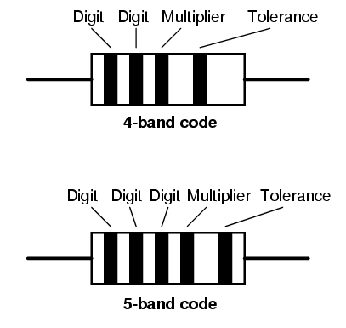
- Resistors are color coded as they are too small for the value to be written on them.
- There are 4 or 5 bands of color . Value of a Resistor is decoded from these band of colors.

Reading Value : Step 1
- If our resistor has four color bands ,turn the resistor so that the gold or silver band is on right hand side or the end with more bands should point left.
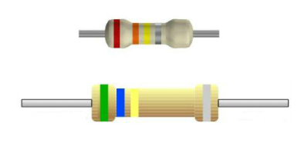
Reading Value : Step 2
The first band is now on the left hand side. This represents the first digit .Based on the color make a note of the digit. In this case- 4 band its ‘5’ and for 5 band its ‘2’.
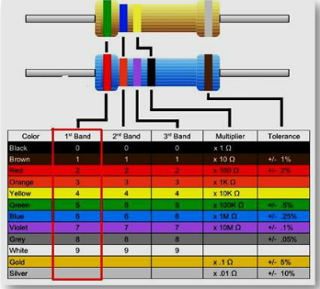
Reading Value : Step 3
The second band represents the second digit. The colors represent the same numbers as did the first digit .In this case -4 band its’6’ and for 5 band its’3’.
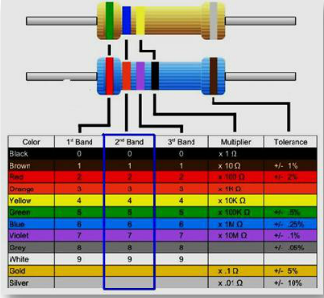
Reading Value : Step 4
The third band divulges how many zeros to add/divide to the first two numbers –for a 4 band Resistor . In this case – 4 band its ‘4’ zeroes to be added . So value is 560K.
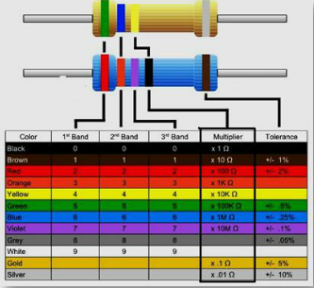
Reading Value : Step 5
The third band denotes the 3rd digit – for a 5 band Resistor. In this case -5 band its ‘7’ . So the value of the 5 band resistor is 237 Ohms as its multipier digit is ‘0.
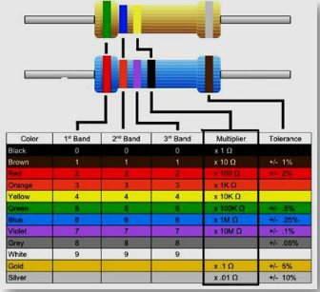
Tolerance
The last band denotes the tolerance . So the value of the 4 band resistor it is +/- 10% while for the 5 band resistor it is +/- 1%.
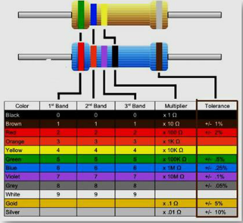

  - Tolerance of a Resistor is also an important property to consider .
  - A 100 ohm resistor with a 10 % tolerance can mean its value can be any fixed value between 90 to 110 Ohms.
  - A 120 Ohm resistor with a 10 % tolerance can mean its value can be any fixed value between 108 and 132 Ohms.
  - So there is some overlap between 100 Ohm and 120 Ohm resistance in terms of its limits.

Mnemonic to Remember
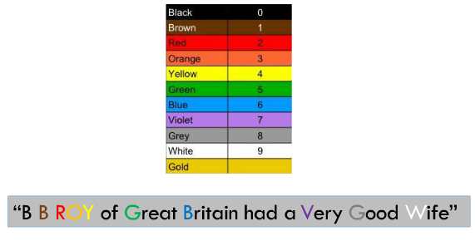
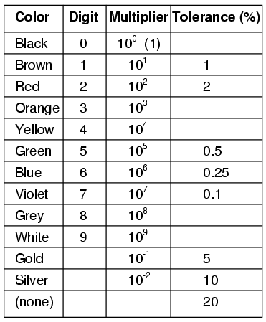
Carbon Film Resistors
  - Most general purpose ,cheap resistor
  - Tolerance of Resistance value is usually +/- 5%
  - Power ratings of 1/8 W ,1/4 W and ½ W are usually used
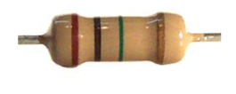

Metal Film Resistor
  - Used when higher tolerance is needed , i.e. more value.
  - They have about +/- 0.05% tolerance
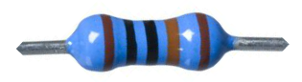

Wire Wound Resistors
  - A wire wound resistor is made of metal resistance wire, and because of this they can be manufactured to precise values
  - Also, high wattage resistors can be made by thick wire material
  - Wire wound resistors in a ceramic case are called as ceramic resistors
quiz :

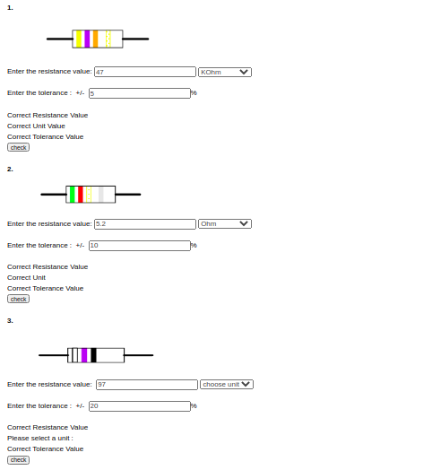
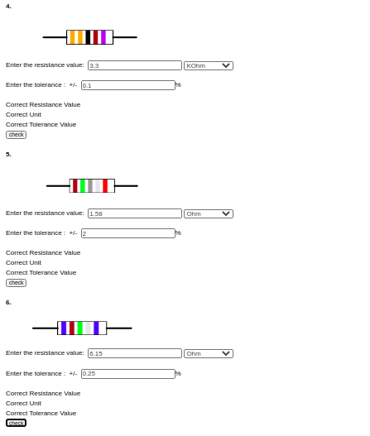

CAPACITORS:

Objectives:
To understand and explain the properties and function of different types of capacitor.

What is Capacitor?
It is one of the passive components like resistor. Capacitor is also known as condenser. Capacitor is generally used to store the charge. The charge is stored in the form of “electrical field”. Capacitors play a major role in many electrical and electronic circuits.
Construction of a Capacitor
The basic construction of all capacitors is of two parallel metal plates separated by an insulating material (the dielectric). An insulator is a material which is non-conducting i.e. it shows a high resistance to letting to electric used is air, other types are oil or paper. Real capacitors are made by taking thin strips of metal foil and the appropriate dielectric material and sandwiching them together.
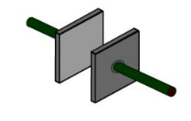
Capacitor achieve large area (thus large capacitance) by doing something tricky, such as putting a dielectric between 2 layers of metal foil and rolling it up.

Capacitance
The capacitance of a capacitor is defined as the ratio of the maximum charge that can be stored in a capacitor to the applied voltage across its plates. In other words, capacitance is the largest amount of charge per volt that can be stored on the device.
Maximum Working Voltage
If the voltage across a capacitor is too high, the insulator between the plates fails to insulate and charge passes from one plate to the other. Capacitor are usually marked with the maximum working voltage to help the user avoid situation.
A good rule of thumb is to never place a voltage across the capacitor which exceeds about two thirds of this value, especially for alternating current circuits.

Mathematical Notation
- Static description
q = cv
q = total charge, c = capacitance, v = voltage across capacitor
- Dynamic description
q = cv
differentiate w.r.t dt
dq/dt = c (dv/dt) dq/dt = i(current)
I = c(dv/dt)

Classification of Capacitors

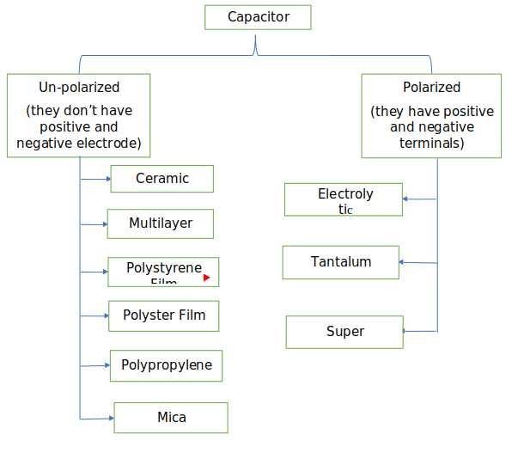

Ceramic Capacitors
Ceramic capacitors are the most used capacitors in the electronics industry. Ceramic capacitors are fixed capacitance type capacitors and they are usually very small (in terms of both physical dimensions and capacitance). The capacitance of ceramic capacitors is usually in the range of picofarads to few micro farads (less than 10µF). They are non-polarised type capacitors and hence can be used in both DC as well as AC circuits.

Electrolytic Capacitor
Electrolytic capacitors are polarized and they must be connected the correct way round , atleast one of their leads will be marked + or – . It is very easy to find the values of electrolytic capacitors because they are clearly printed with their capacitance and voltage rating.
Tantalum Capacitor
Tantalum bead capacitors are polarized and have low voltage ratings like electrolytic capacitors . Usually , the “+” symbol is used to show the positive component lead . Modern tantalum bead capacitors are printed with their capacitance voltage and polarity in full. However older ones use a color – code systems which has two stripes (for the two digits ) and a spot of color for the number of zeros to give the value in uF.
Un-polarized Capacitors- small values(upto 1uF)
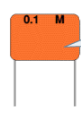
The value printed but without a multiplier, so you need to use experience to work out what the multiplier should be! For example 0.1 means 0.1 pF. Sometimes the multiplier is used in place of the decimal point: For example: 4n7 means 4.7nF.

Un-polarized Capacitors — Capacitor Number Code
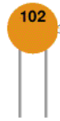
A number code is often used on small capacitors where printing is difficult: The 1st number is the 1st digit, the 2nd number is the 2nd digit, the 3rd number is the number of zeros to give the capacitance in pF. Ignore any letters - they just indicate tolerance and voltage rating. For example: 102 means 1000pF (not 102pF!) For example: 472J means 4700pF (J means 5% tolerance).
Capacitors in series
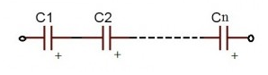
Figure: 20
q = q1 = q2 = q3 ………
i = i1 = i2 = i3 ………

where
q = total charge, i = capacitive current
When the capacitors are connected in series Charge and current is same on all the capacitors.
For series capacitors same quantity of electrons will flow through each capacitor because the charge on each plate is coming from the adjacent plate. So, coulomb charge is same. As current is nothing but flow of electrons, current is also same.
for series, in steady state
v = v1 + v2 + v3 ……..
q/c = q/c1 + q/c2 + q/c3 ………
Equivalent Capacitance ,1/c = 1/c1 + 1/c2 + 1/c3 ……

Capacitors in parallel
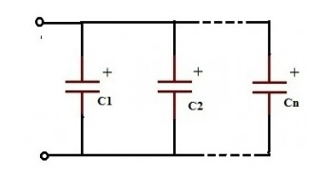
Figure: 21
All the capacitors which are connected in parallel have the same voltage .
v = v1 = v2 = v3 …..
where v = voltage applied between the input and output terminals of the circuit.
For parallel combination
i = i1 + i2 + i3 + … (i = total current)
so,
Equivalent Capacitance, c = c1 + c2 +c3…..
Charging and Discharging
We say that the capacitor is charged up when connected to P and discharged when moved to.
Charging
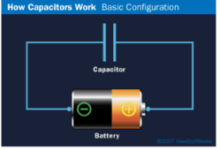
The plate on the capacitor that attaches to the negative terminal of the battery accepts electrons that the battery is producing . The plate on the capacitor that attaches to the positive terminal of the battery loses electrons to the battery. Once it’s charged , the capacitor has the same voltage as the battery.
Discharging
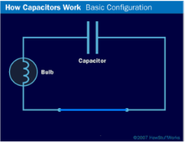
If we then remove the battery and replace it with a wire , current will flow from one plate of the capacitor to the other. The bulb will light initially and then dim as the capacitor discharges , until it is completely out.
Application of capacitor
- Energy storage
- Power conditioning
- Power factor correction
- Suppression and coupling

INDUCTOR :

To study function of inductor and factors influencing inductance.

Theory
Function of an Inductor
In an electronic circuit, the resistor is used to control the amount of current that flows through a conductor.
Mother device that controls the current is the inductor .
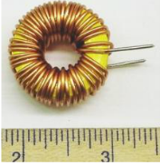
Figure:3
However unlike the resistor that affects the current uniformly at all times, the inductor only affects currents when the value of current is change.
Similarity with Capacitor
- Rate of change of voltage in a capacitor depends upon the current through it
- Rate of change of current in an inductor depends upon the voltage applied across it.
- Like capacitive current , inductive current is not simply proportional to voltage
- Unlike the situation in a resistor, the power associated with inductive current (V times I) is not turned into heat but is stored as energy in the inductor’s magnetic field.

Equation of an Inductor
V= L* dl / dt
- L is the inductance and is measured in henry.
- Putting a voltage across an inductor causes the current to rise as a ramp
- 1 volt across 1 henry produces a current that increases at 1 amp per second
Structure of an Inductor
It consists of a wire wound as a coil around a core. The core may consist of a air filled hollow tube or solid material.
Inductance
The amount of inductance in henries a coil has, is determined by the following factors -
- No of turns of wire wound around the coil
- Cross sectional area of the coil
- The material type of the coil
- The Length of the coil
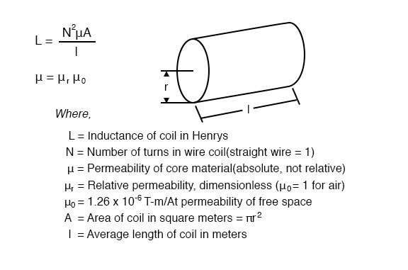

Inductors in series
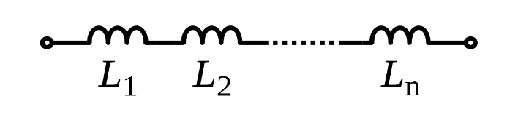
The current is same in all three inductors,
i.e., I₁ = I₂ = I₃
V= L (di/dt)
V_{Total} = V_{L1} + V_{L2} + V_{L3} …………(Series combination)
V_{T} = L₁ (dI₁/dt) + L2 (dI2/dt) + L3 (dI3/dt)
Since current is same in all three, thus let I₁ = I2 = I3 = I
V_{T} = L₁ (dI/dt) + L2 (dI/dt) + L3 (dI/dt)
L_{equi}(dI/dt) = (dI/dt) (L₁ + L2 + L3)
L_{equi} = (L₁ + L2 + L3)
In general, L_{equi} = (L₁ + L₂ + L₃ + ……..L_{n}) [for ‘n’ inductors in series]

Inductors in parallel
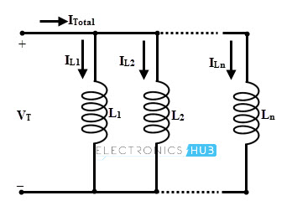
Voltage same in all inductors
V_{Total} = V_{L1} = V_{L2} = V_{L3} . . . . = V_{n}
V= L (di/dt)
I_{Total} = I_{L1} + I_{L2} + I_{L3} . . . . + I_{n} …………(parallel combination)
⇒ L_{equi} d/dt (I_{L1} + I_{L2} + I_{L3} . . . . + In)
⇒ L_{equi} ( (d_{i1})/dt + (d_{i2})/dt + (d_{i3})/dt . . . .)
Substituting V / L in place of di/dt, the above equation becomes
V_{T} = L_{equi} (V/L₁+ V/L₂ + V/L3 . . . .)
As the voltage drop is constant across the circuit, then v = V_{T}. So we can write
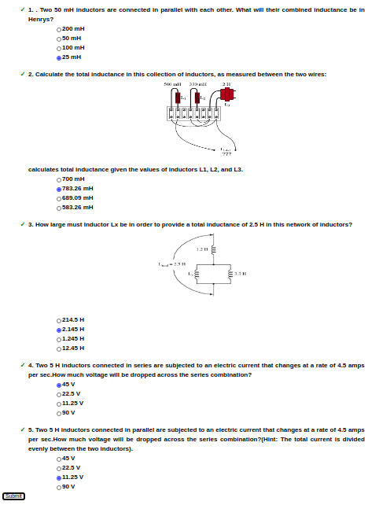
1/ L_{equi} = 1/L₁ + 1/L₂+ 1/L₃. . . .
QUIZ:

MULTIMETER :

A multimeter or a multitester, also known as a volt/ohm meter or VOM, is an electronic measuring instrument that combines several measurement functions in one unit. A typical multimeter may include features such as the ability to measure voltage, current and resistance. Multimeters may use analog or digital circuits—analog multimeters and digital multimeters (often abbreviated DMM or DVOM.) Analog instruments are usually based on a microammeter whose pointer moves over a scale calibration for all the different measurements that can be made; digital instruments usually display digits, but may display a bar of a length proportional to the quantity measured.A multimeter can be a hand-held device useful for basic fault finding and field service work or a bench instrument which can measure to a very high degree of accuracy. They can be used to troubleshoot electrical problems in a wide array of industrial and household devices such as electronic equipment, motor controls, domestic appliances, power supplies, and wiring systems.
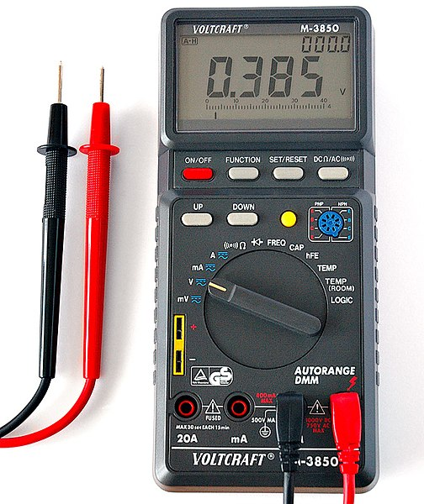

Ohm’s Law :

Objectives:
At the end of the experiment, the student would be able to
- Explain Ohm's Law
- Explain Ohm's Law for Resistance in series
- Explain Ohm's Law for Resistance in parallel
- Explain Non Ohmic Device
- Measure and confirm Ohms Law

THEORY :

Ohm’s law states that the current through a conductor between two points is directly proportional to the voltage across the two points. Such a conductor is characterized by its ‘Resistance’ – R measured in Ohms.
According to ohm’s law :
V=I×R

where,
V is the Voltage in Volts across the conductor.
I is the current in Amperes through the conductor.
Voltage(V) is directly proportional to current i.e V=I×R
Resistance(R) in inversely proportional to current(I) i.e I = V / R

Ohm’s Law Triangle:
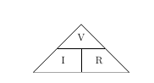

Figure 1: Ohm's Law triangle
From the above figure, the equation may be represented by a triangle known as Ohm's Law triangle, where V (voltage) is placed on the top section, the I (current) is placed to the left section, and the R (resistance) is placed to the right. The line that divides the left and right sections indicates multiplication, and the divider between the top and bottom sections indicates division.
Therefore equations derived from Ohm's law triangle are
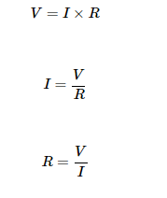
Explanation of Ohm's Law
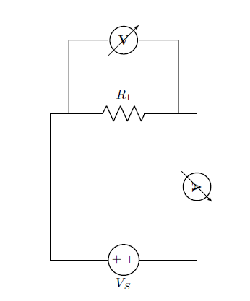
From the circuit:

The voltage across resistor is equal to source voltage: V_{R}=V_{S}
The current through the resistance is given by: I=V_{R}/R
Explanation of Ohm's Law for Resistance in series
Series circuits are sometimes called current-coupled or daisy chain-coupled. The current in a series circuit goes through every component in the circuit. Therefore, all of the components in a series connection carry the same current. There is only one path in a series circuit in which the current can flow.

Current: I = I₁ = I₂ = I₃
Resistance: R_{eq}=R₁+R₂+R₃
Voltage: V_{S}=V_{R1}+V_{R2}+V_{R3}
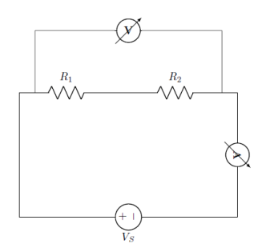Series Resistors
From the circuit:

The equivalent resistance,
R_{eq}=R₁+R₂

The total current of the circuit,
I_{T}=V_{S} / R_{eq}

Voltage across each resistance are,
For resistance R1,
V_{R1}=R₁×I_{T}

For resistance R2,
V_{R2}=R₂×I_{T}

In a series circuit, the current through each of the resistors is the same, and the voltage across the circuit is the sum of the voltages across each resistor.
Explaination of Ohm's Law for Resistance in parallel

If two or more components are connected in parallel they have the same potential difference (voltage) across their ends. The potential differences across the components are the same in magnitude, and they also have identical polarities. The same voltage is applicable to all circuit components connected in parallel. The total current is the sum of the currents through the individual components, in accordance with Kirchhoff’s current law.

Voltage:
V=V₁=V₂=V₃

Resistance:
1/R_{eq}=1/R₁+1/R₂+1/R₃

Current:
I_{T}=I_{R1}+I_{R2}+I_{R3}

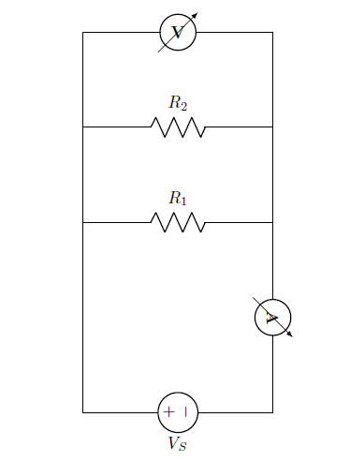
From the circuit:

The equivalent resistance,
R_{eq}=(R₁×R₂)/(R₁+R₂)

The total current of the circuit,
I_{T}=V_{S}/R_{eq}

Current across each resistance are,
For resistance R₁,
I_{R1}=V_{S}/R₁

For resistance R₂,
I_{R2}=V_{S}/R₂

In a parallel circuit, the voltage across each of the resistors is the same, and the total current is the sum of the currents through each resistor.

Explanation of Non Ohmic Device

A Non ohmic device is a device that does not obey Ohm's Law i.e. the resistance is not constant, but changes in a way that depends on the voltage across it.The device is said to be non-Ohmic. In this case V versus I graph is not a straight line, but has some curvy shape. Such devices do not have a constant value of resistance and the resistance is called dynamic resistance because it is constantly changing. Examples of such devices are tungsten filament (bulb), diode, thermistor etc.
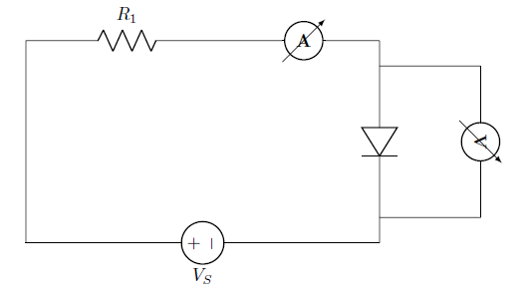
Note
Ohms Law is a very useful law but it only applies to devices that behave like resistors – ie – I is simply proportional to V.
Ohms Law describes one possible relationship between V and I in a component, but there are others, like
Capacitors ( I proportional to rate of change of V )
Diodes ( I flows in only 1 direction )
Thermistors ( Temperature dependent resistors )

Ohm’s law
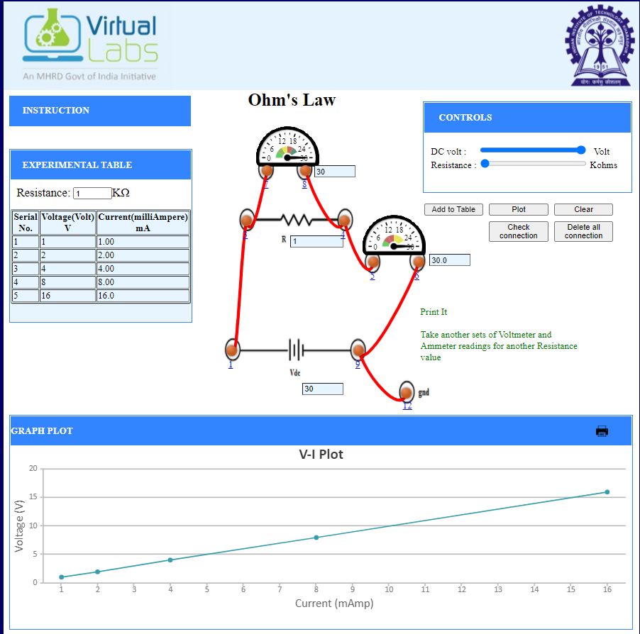

Ohm’s law(Resistor in Series)
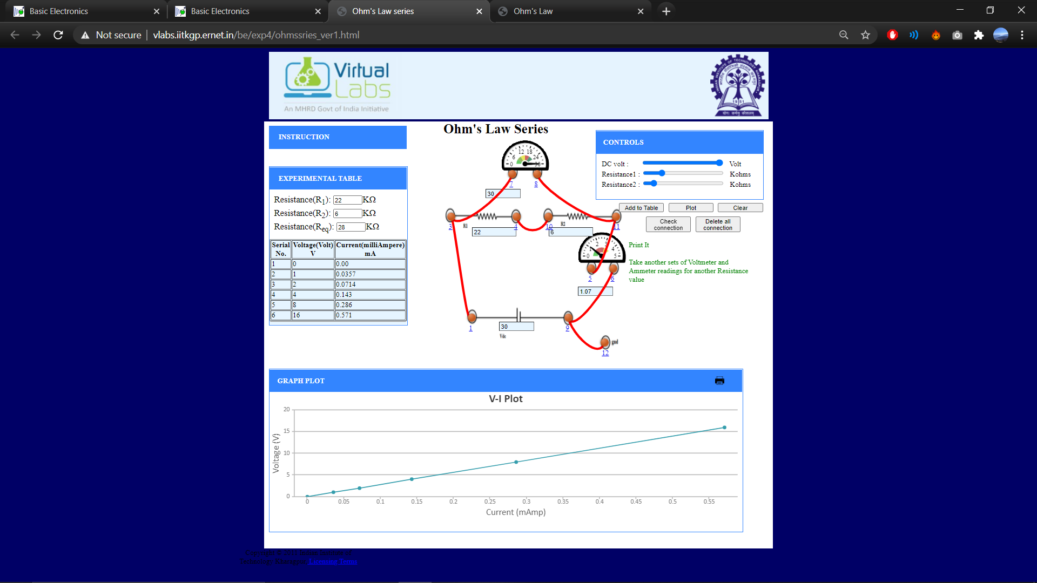

Ohm’s law (Resistor in Parallel)

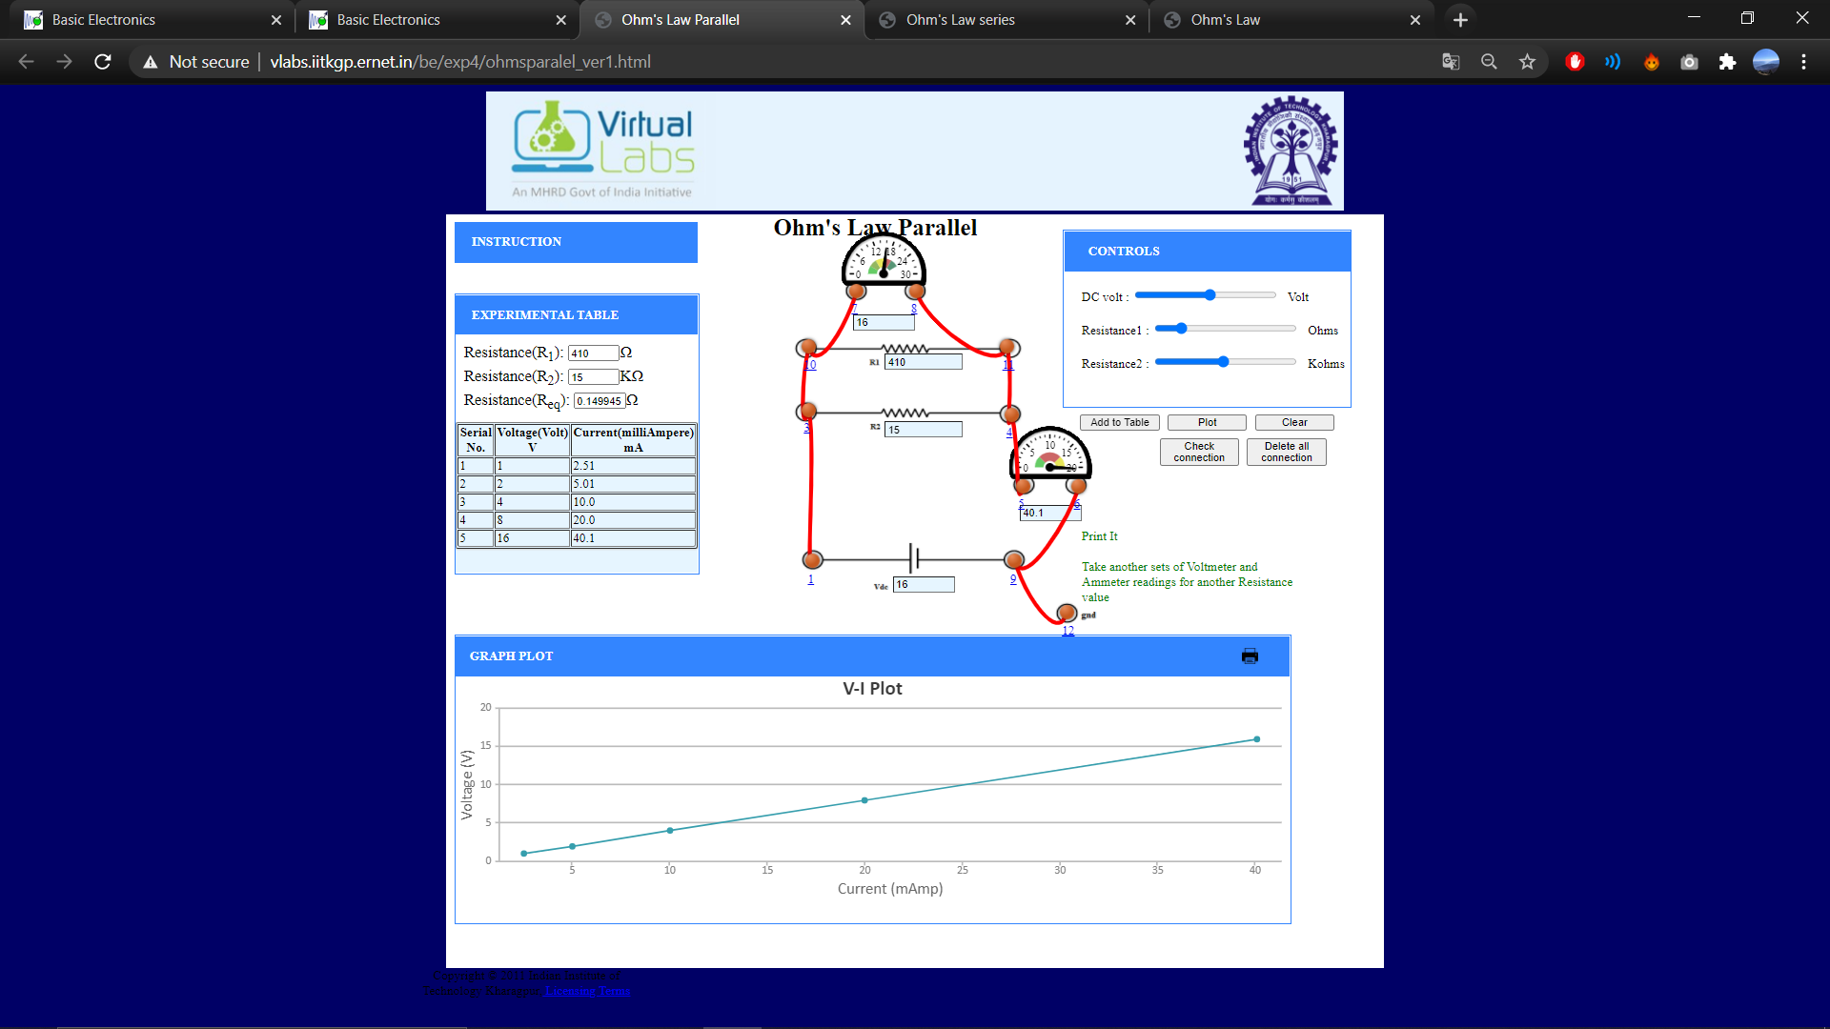
Non-Ohmic Device Verification:

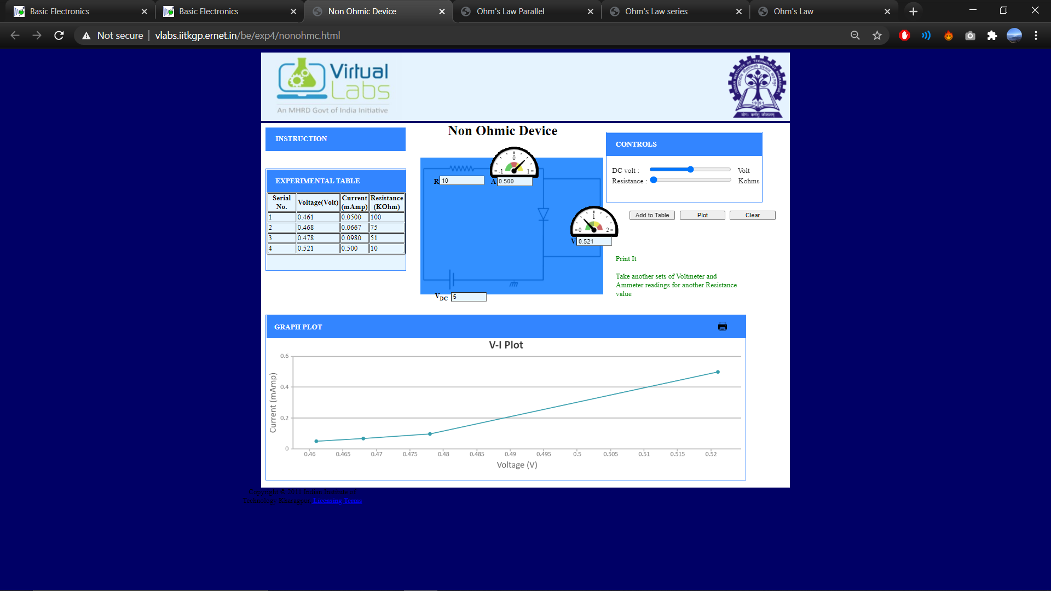

Quiz:

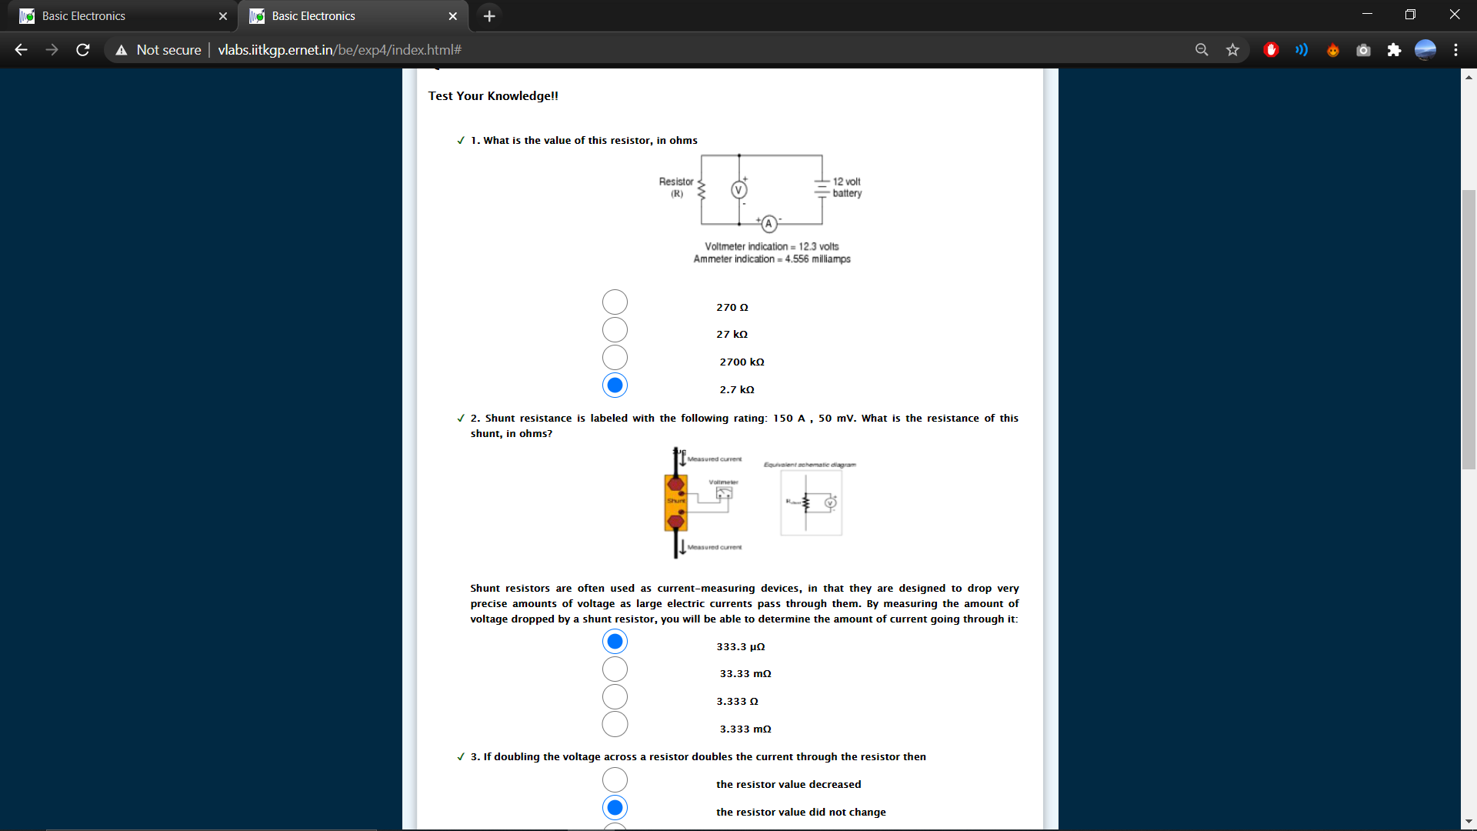

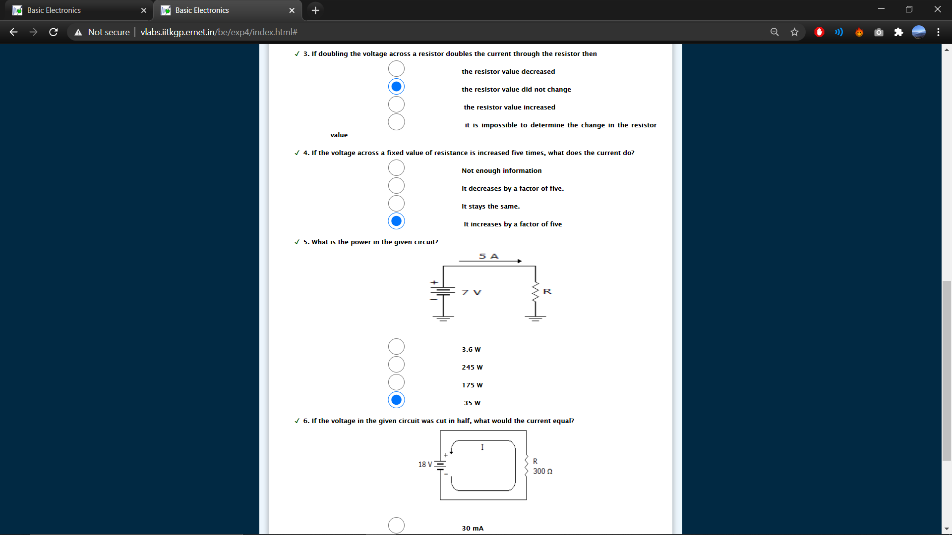
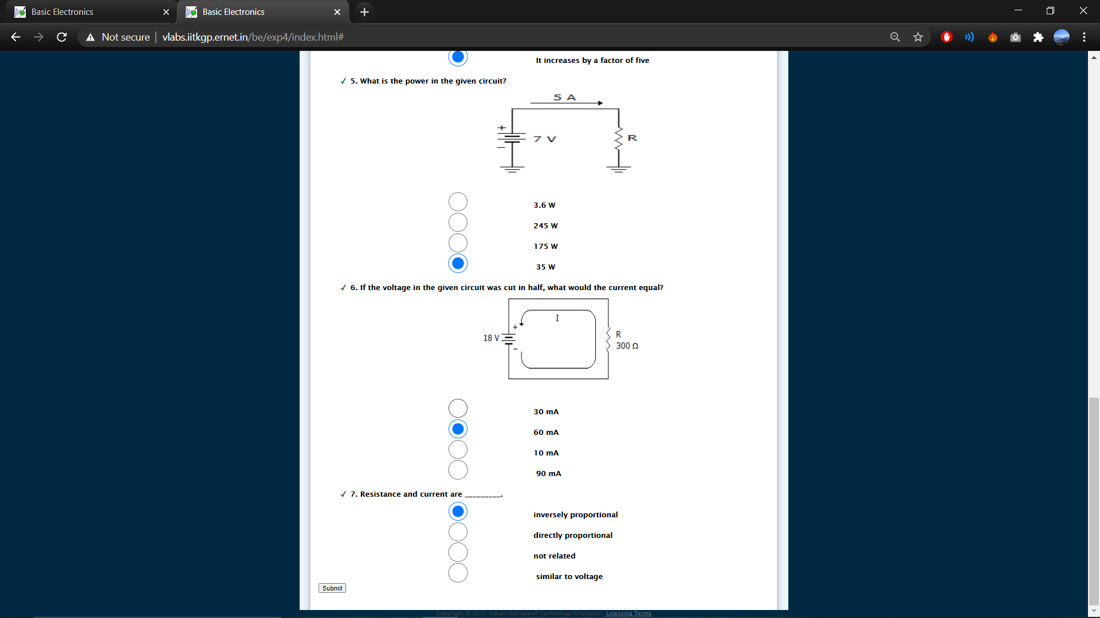

EXPERIMENT-2

Lab No: 2

Lab Name: Explain VI Characteristics of a Diode

Objectives:
At the end of the experiment, the student should be able to
- Explain the structure of a P-N junction diode
- Explain the function of a P-N junction diode
- Explain forward and reverse biased characteristics of a Silicon diode
- Explain forward and reverse biased characteristics of a Germanium diode

Theory:

Structure of a P-N junction diode:

The diode is a device formed from a junction of n-type and p-type semiconductor material. The lead connected to the p-type material is called the anode and the lead connected to the n-type material is the cathode. In general, the cathode of a diode is marked by a solid line on the diode.

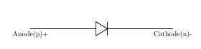
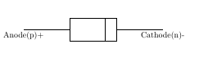

Figure:1 Figure:2

Forward Biased PN Junction Diode:
When a diode is connected in a Forward Bias condition, a negative voltage is applied to the N-type material and a positive voltage is applied to the P-type material. If this external voltage becomes greater than the value ofthe potential barrier, approx. 0.7 volts for silicon and 0.3 volts for germanium, the potential barriers opposition will be overcome and current will start to flow. This is because the negative voltage pushes or repels electrons towards the junction giving them the energy to cross over and combine with the holes being pushed in the opposite direction towards the junction by the positive voltage. This results in a characteristics curve of zero current flowing up to this voltage point, called the “knee” on the static curves and then a high current flow through the diode with little increase in the external voltage/

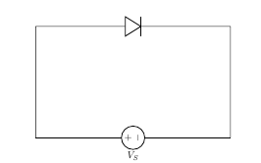

Figure:1

Reverse Biased PN Junction Diode:

When a diode is connected in a Reverse Bias condition, a positive voltage is applied to the N-type material and a negative voltage is applied to the P-type material .The positive voltage applied to the N-type material attracts electrons towards the positive electrode and away from the junction, while the holes in the P-type end are also attracted away from the junction towards the negative electrode . The net result is that the depletion layer grows wider due to a lack of electrons and holes and presents a high impedance path, almost an insulator and a high potential barrier is created across the junction thus preventing current from flowing through the semiconductor material.
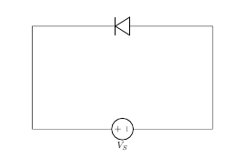

Figure:4

Diode Equation:

In the forward-biased and reversed-biased regions, the current (I_{f}), and the voltage (V_{f}), of a semiconductor diode are related by the diode equation:

I_{f}=I_{s}×(exp^{(Vf /n×VT)}−1)

where,
I_{s} is reverse saturation current or leakage current,
I_{f} is current through the diode(forward current),
V_{f} is potential difference across the diode terminals(forward voltage)
V_{T} is thermal voltage, given by
V_{T} = (k×T )/q
and
k is Boltzmann’s constant = 1.38x10−23 J /°Kelvin,
q is the electronic charge = 1.6x10−19 joules/volt(Coulombs),
T is the absolute temperature in °Kelvin(°K = 273 + temperature in °C),
At room temperature (25 °C), the thermal voltage is about 25.7 mV,
n is an empirical constant between 0.5 and 2

The empirical constant, n, is a number that can vary according to the voltage and current levels. It depends on electron drift, diffusion, and carrier recombination in the depletion region. Among the quantities affecting the value of n are the diode manufacture, levels of doping and purity of materials.

If n=1, the value of k×T / q is 26 mV at 25°C.
When n=2, the value of k×T / q becomes 52 mV.
For germanium diodes, n is usually considered to be close to 1. For silicon diodes, n is in the range of 1.3 to 1.6

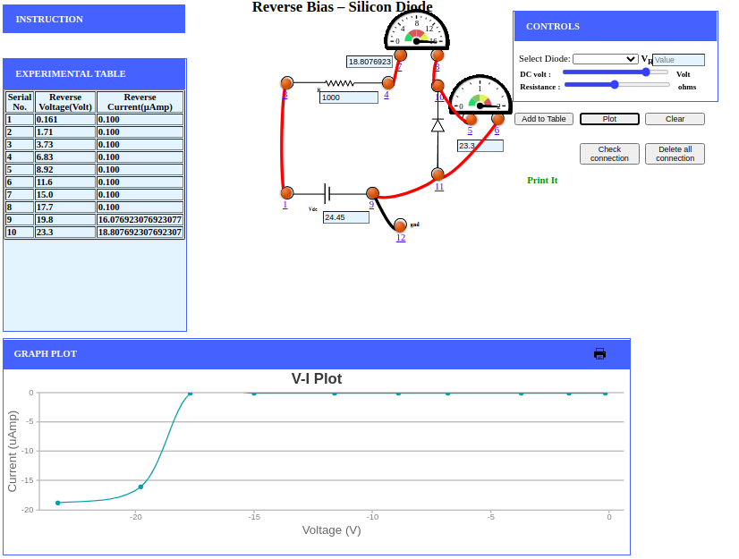
silicon diode reverse-biased:

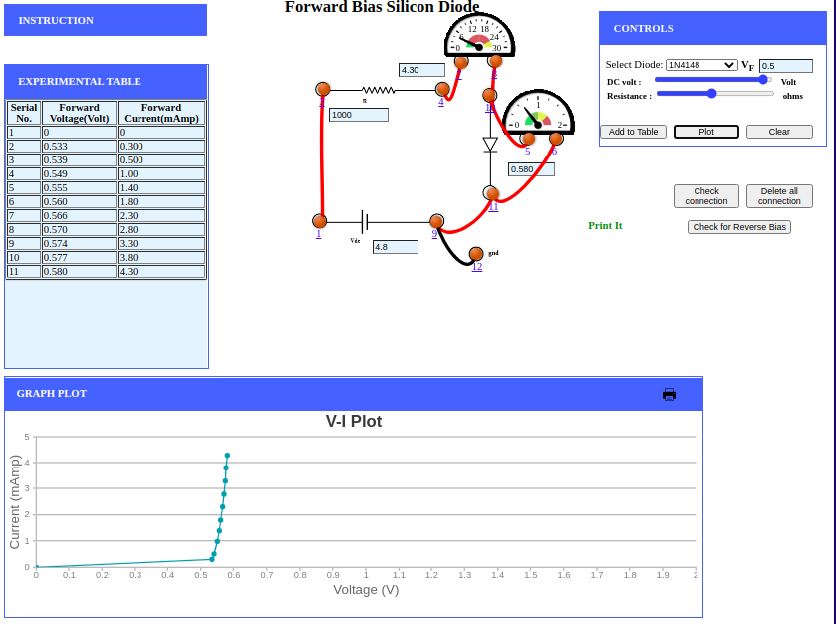
silicon diode forward-biased:

Ge diode Reverse-biased :

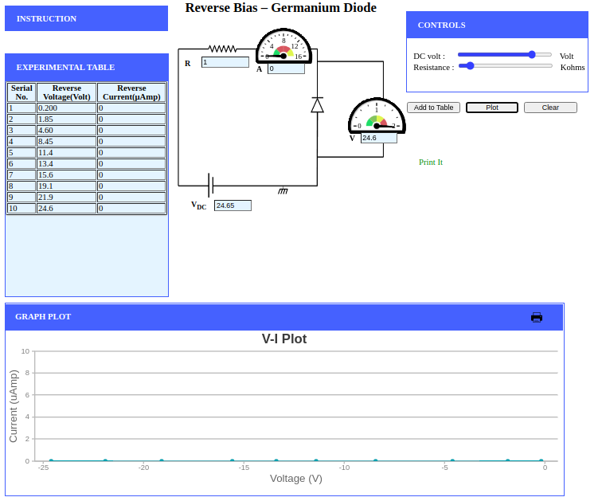

Ge diode forward-biased:
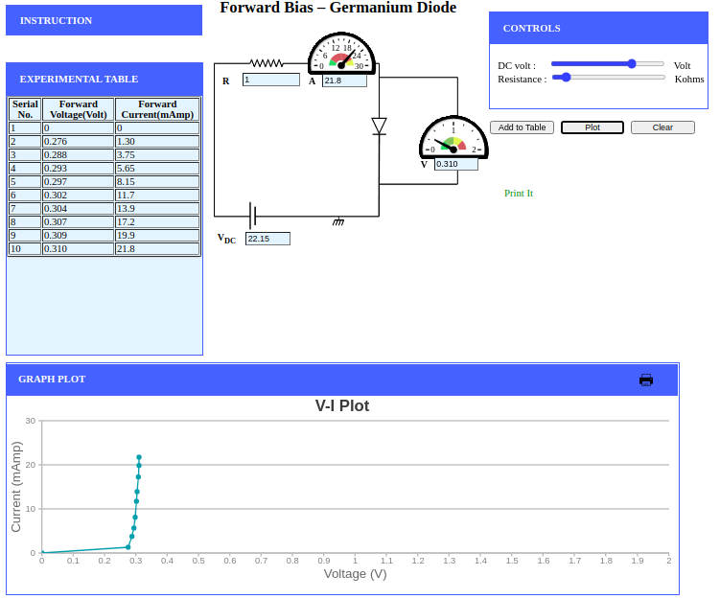
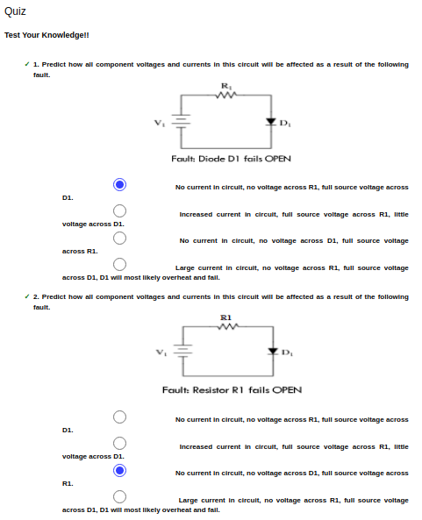

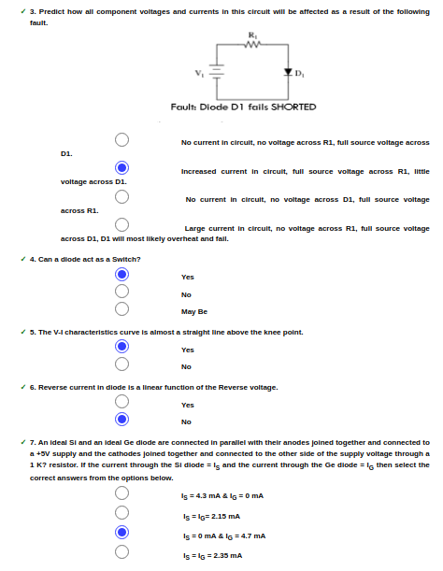
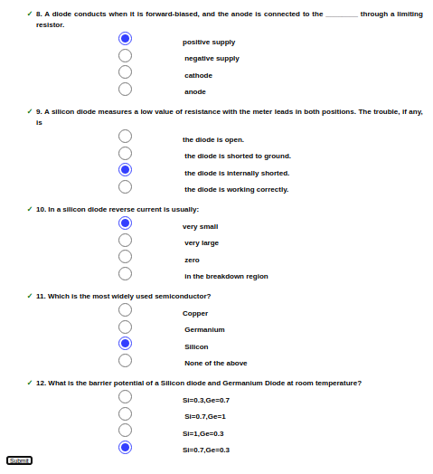
EXPERIMENT-3

Lab No: 3

Lab Name: To study Half Wave Rectification

Theory:
- RECTIFICATION
A rectifier is a device that converts alternate current (AC) to direct current (DC). It is done by the using of a diode or a group of diode.
A process is known as rectification
- HALF WAVE RECTIFIER
When a standert AC waveform is passed through a half wave rectifier ,only half of the AC waveform remains. Half wave rectifier only allows one half cycle(Positive or negative halfcycle) of the AC voltage through and it will block or not converted the other half cycle to DC. And in the positive cycle the diode is forward biased and on the negative cycle the diode is reverse biased by diode we convert AC source into a pulsating DC source. The circuit is simple the combination of a single diode in series with a resistor where the resistor is acting as a load.

- HALF WAVE RECTIFICATION – WAVEFORM

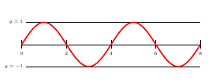

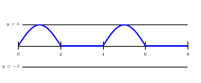
The output DC voltage of halfwave rectifier is.

Vpeak=Vrms×√2
Vdc=Vpeak/Π

- HALF WAVE RECTIFICATION : FOR POSITIVE HALF CYCLE
When AC input is applied to the diode so during the positive half cycle of the signal. The diode is forward biased and allows electric current but when it is in the negative half cycle the diode is reverse biased and the diode block the flow of current until the positve half cycle is not come.

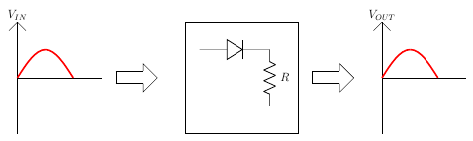

For positive half cycle:
VI−Vb−I×rd−I×R=0
WHERE,
VIVI is the input voltage,
VbVb is barrier potential,
rdrd is diode resistance,
II is total current,
RR is resistance
I=VI−Vb/rd+R
VO=I×R
VO=VI−Vbrd+R×R
For rdr<< R,
VO=VI−Vb

Vb is 0.3 for Germanium ,
Vb is 0.7 for Silicon
For VI<Vb,
The diode will remain OFF.The Output voltage will be,
VO=0
For VI>Vb,
The diode will be ON.The Output voltage will be,
VO=VI−Vb

- HALF WAVE RECTIFICATION : FOR NEGATIVE HALF CYCLE
When AC input is applied to the diode so during the negative half cycle of the signal.the diode is reverse biased and the diode block the flow of current and acts as a open circuit and do not pass wave form through diode.
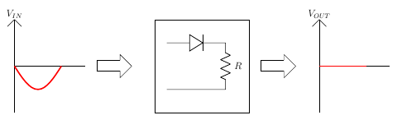
FOR NEGATIVE HALF CYCLE:
VO=0 Since, I=0
Half wave Rectification : For an Ideal Diode
For Ideal Diode,
Vb=0
For positive half cycle,
VO=VI
For negative half cycle,
VO=0

Average output voltage
VO=Vm×sinwt for 0≤wt≤π
VO=0 for π≤wt≤2π
Vav=Vm/π=0.318Vm
RMS load voltage
Vrms=Irms×R=Vm/2
Average load current
Iav=Vav/R=Vm/π/R
Iav=Vm/π×R=Im/π
RMS load current
Irms=Im/2
Form factor: It is defined as the ratio of rms load voltage and average load voltage.
F.F=VrmsVav
F.F=Vm2Vav2=π2=1.57
F.F≥1
rms≥av
RIPPLE FACTOR
γ=√(F.F2−1×100%
γ=√(1.572−1)×100%=1.21%

PEAK INVERSE VOLTAGE
It is a maximum voltage that the rectifing diodes has to withstand when it reversed biased the peak inverse voltage rating of a diode is of the primary important in the design of rectification system. The portion of the sinusoidal waveform which repeats or duplicates itself is known as the cycle. The part of the cycle above the horizontal axis is called the positive half-cycle, the part of the cycle below the horizontal axis is called the negative half cycle. With reference to the amplitude of the cycle, the peak inverse voltage is specified as the maximum negative value of the sine-wave within a cycle's negative half cycle.

PIV=V
−Vm+V=0⇒V=Vm
PIV≥Vm
OUTPUT:
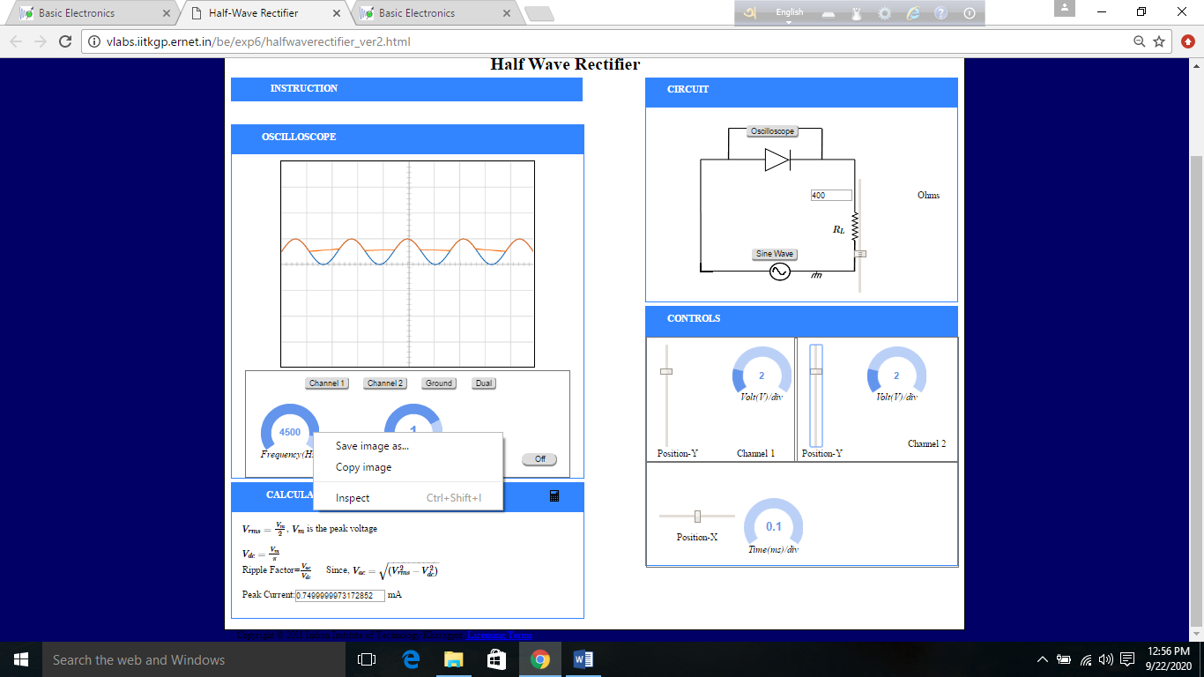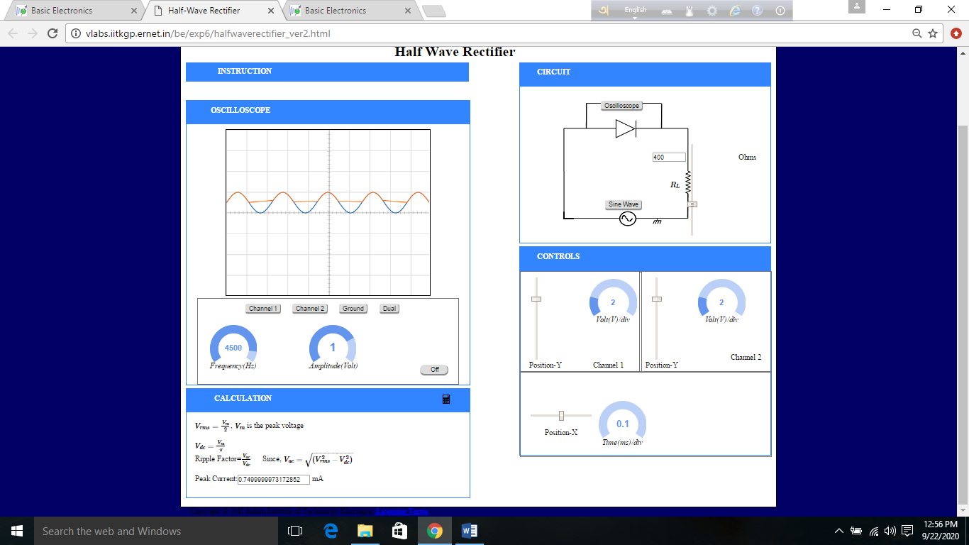

QUIZ:

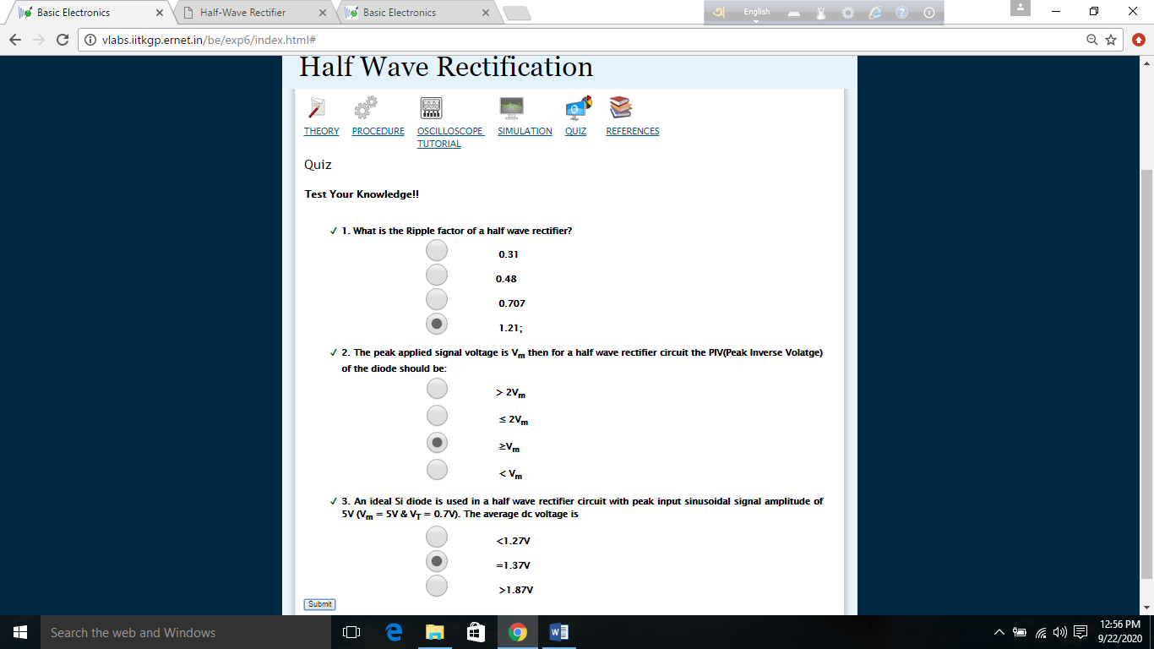

EXPERIMENT-4

Lab No: 4

Lab Name: To Study Full Wave Rectification

Theory:
Rectification:
A rectifier circuit is circuit which rectifies AC voltage. Rectification is the correction of the errors or mistakes. A rectifier is a device that converts alternating current (AC) to direct current (DC). So if we input AC current in a rectifier then by rectification we will get DC current.
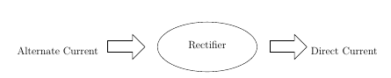
There are two types of rectifier. They are:
- Half Wave Rectifier
- Full Wave Rectifier

Full Wave Rectifier:
By using the full wave rectifier we can improve the DC output. The Rectified output obtained from sinusoidal input up to 100%. We can improve the rectified the output up to 100% by using the full wave rectifier. It allows unidirectional current and converts the input waveform to one constant polarity. By adding input waveform two half wave rectifier in the phase of 0 degrees and 180 degrees,
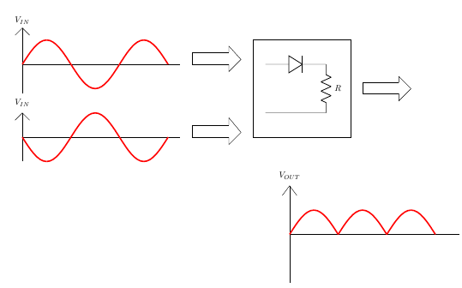
Full Wave Rectifier Circuit:
In that circuit, there are two sources with phase difference between them. In the circuit given below there are two voltage source (V1, V2) and two diodes (D1, D2) and the characteristics of these voltage sources and diodes are vice-versa. If V1 is positive then V2 will be negative and long with that D1 will be short circuit and D2 will be open circuit. But if V1 is negative and V2 is positive, then then D1 will be open circuit and D2 will be short circuit.
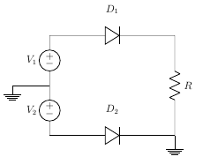

Full Wave Rectifier Waveform:
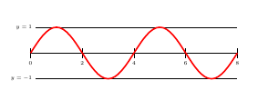
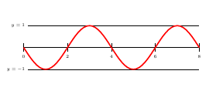
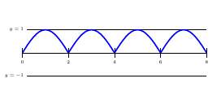
Full Wave Bridge Rectifier:
There are 4 diodes in the bridge rectifier circuit (D1, D2, D3, D4) connected as a bridged connection. And there is a load resistance R. We need to calculate the output voltage according to the resistance.
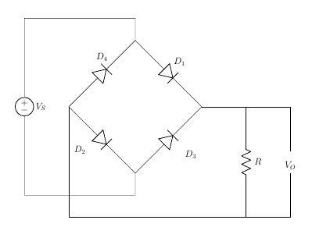

Positive Half Cycle (Bridge Rectifier):
In positive half cycle D1 and D2 are forward biased and D3 and D4 are reverse biased. Here D1 and D2 will be short circuit and D3 and D4 will be open circuit. Diode D1 and D2 are connected as series connection. Circuit diagram will be,
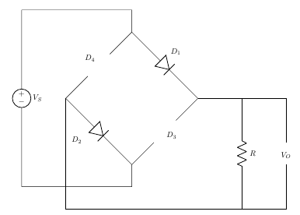
Here ,
VI−VO=0
⇒VO=VI
VO=VI−2×Vb
VO=VI−2×Vb−2×Ird
Here,
VI = the input voltage
Vm= maximum or peak voltage
Vb = barrier potential,
rd = diode resistance

Negative Half Cycle (Bridge Rectifier):
In positive half cycle D3 and D4 are forward biased and D1 and D2 are reverse biased. Here D1 and D2 will be short circuit and D1 and D2 will be open circuit. Diode D3 and D4 are connected as series connection. Circuit diagram will be,
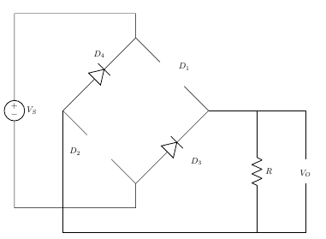

Here,
VI−VO=0
⇒VO=VI

Full Wave Rectifier (Center Tapped):
In the secondary side of the transformer, there are tapping which stands in the center and by center tapping a full wave rectifier constructed. There are 2 diodes and 1 load resistance in this circuit. At any point of time, one of the diodes will be positive and forward biased and another will be negative and reverse biased. Here,
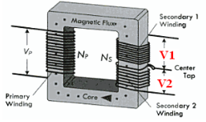

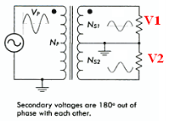

NP/NS=VP/VS=1/2
⇒VS=2×VI

Positive Cycle (Center Tapped):
For the positive half cycle D1 will be the forward biased and D2 will be the reverse biased.
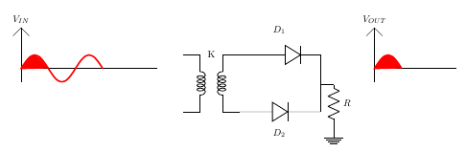

Here, VI−VO=0
⇒VO=VI

Negative Cycle (Center tapped):
For the positive half cycle D2 will be the forward biased and D1 will be the reverse biased.
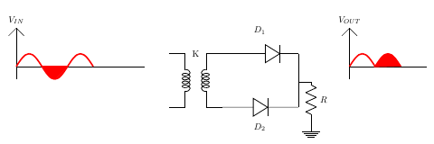

negative Cycle D1 is Reverse Biased and D2 is Forward Biased
here ,
VI−VO=0
⇒VO=VI

Average DC Load Voltage

VO=Vm×sinwt for 0≤wt≤π
Vav=Vdc=(2×Vm)/π

Average Load Current
Iav=VavR=(2×Vm)/(π×R)
Iav=(2×Im)/R

RMS Load Current

I=Im×sin wt for 0≤wt≤π
Irms=Im/√2

RMS Load Voltage
Vrms=Irms × R= Im/√2×R
Vrms=Vm/√2

Form factor:
It is defined as the ratio of rms load voltage and average load voltage.
F.F=Vrms/Vav
F.F=(Vm/√2}/(2×Vm)/π=π2√2=1.1

F.F≥1

Ripple Factor:
γ=√(F.F2−1)×100%
γ=√(1.112−1)×100%=48.1%

Efficiency:
It is defined as ratio of dc power available at the load to the input ac power.
n%=(Pload/Pin)×100%
n%=(Idc^2×R)/(Irms^2×R)×100%
n%=((4×Im^2)/π^2)/((Im^2)/2)×100% = (8/π^2)×100%=81.13%

Peak Inverse Voltage:
This is the maximum voltage that the rectifying diodes has to withstand when it reversed biased the pick inverse voltage rating of a diode is one of the primary important in the design of rectification system.

For Bridge Rectifier,
D1 and D2 is Forward Biased
D3 and D4 is Reverse Biased
Vm−VO=0
⇒VO=Vm
−VO+PIV=0
⇒PIV=Vm
PIV≥Vm

For Center Tapped Rectifier,
D2 is Forward Biased,
PIV at D1,
Vm−VO=0
⇒VO=Vm
VO−PIV+Vm
⇒PIV=2Vm
PIV≥2Vm

Full Wave Rectifier:
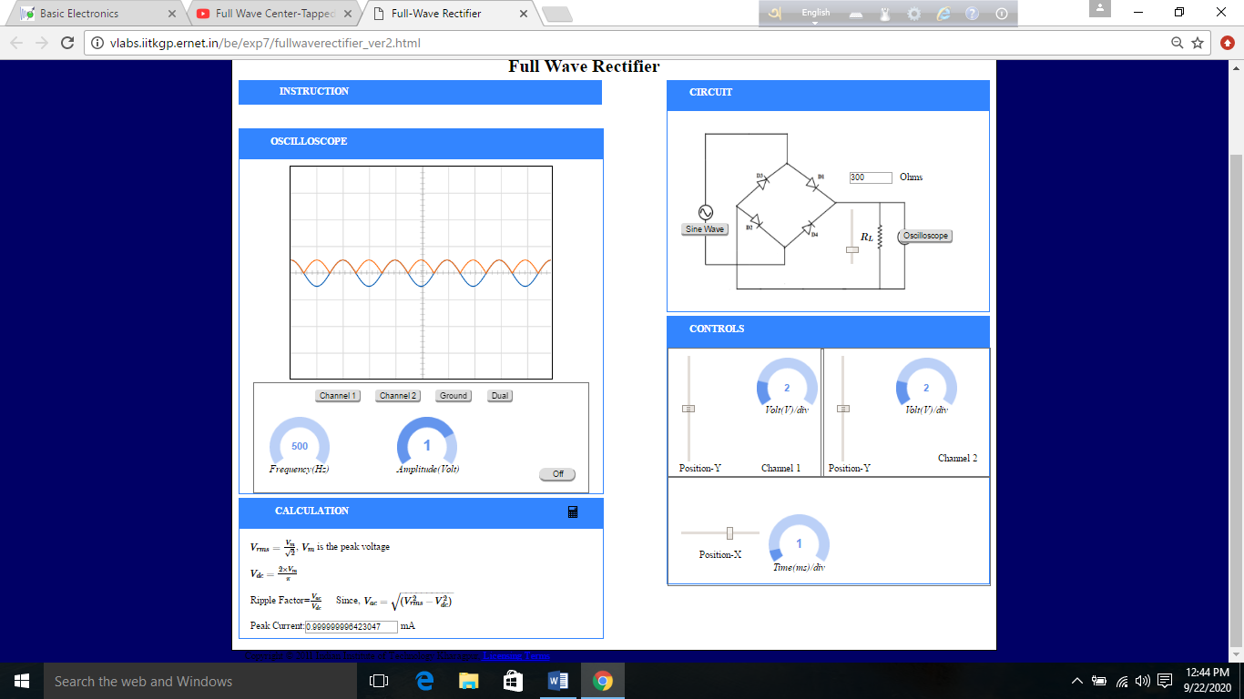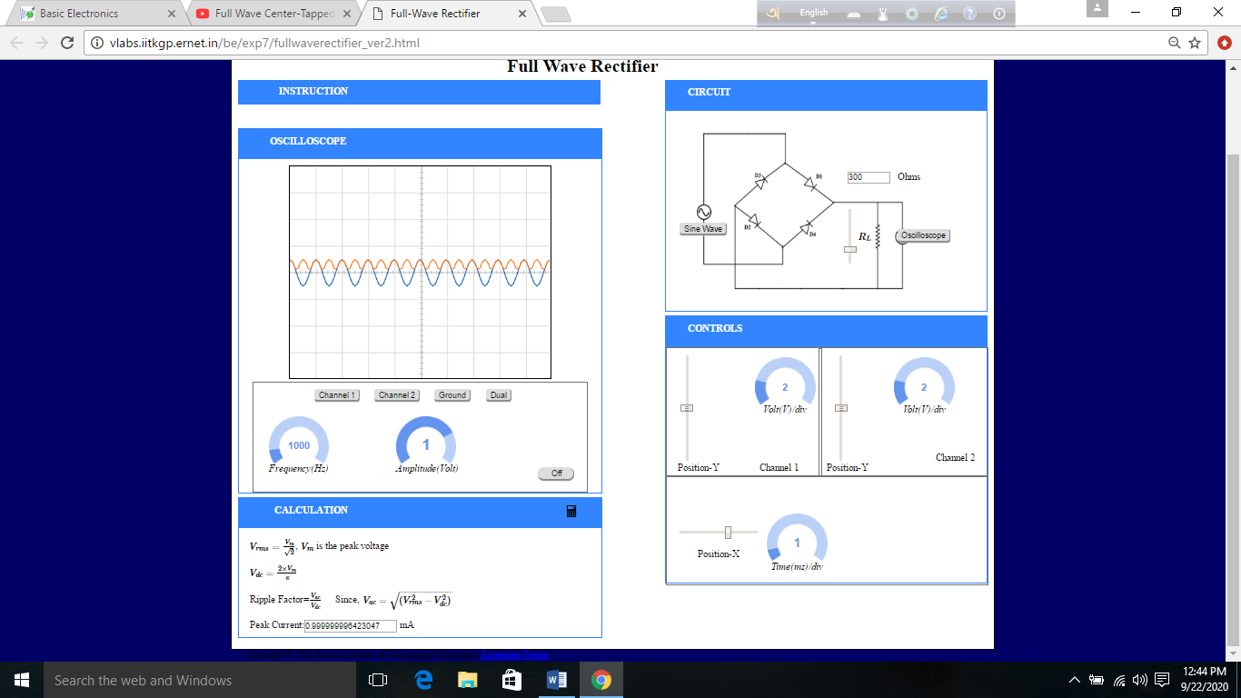

Quiz:
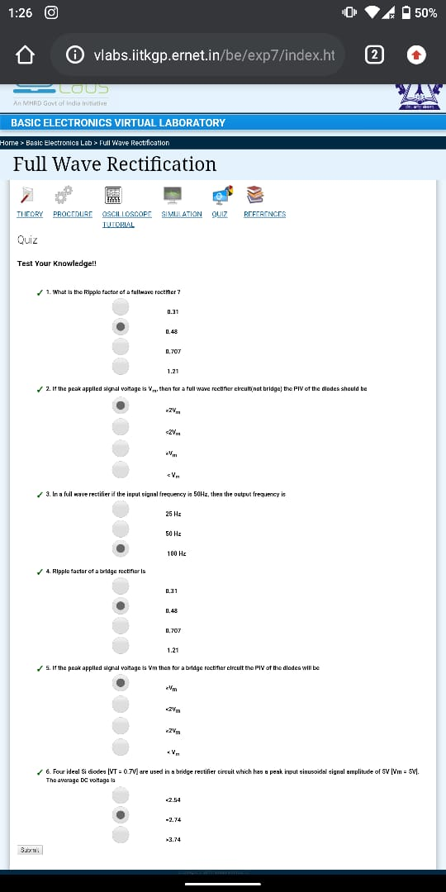

EXPERIMENT-5

Lab No: 5

Lab Name: Capacitative Rectification

Theory :

Rectifier :
A rectifier is a device that converts alternating current (AC) to direct current (DC), a process known as rectification. Rectifiers are essentially of two types – a half wave rectifier and a full wave rectifier. A full wave rectifier allows unidirectional current through the load during the entire sinusoidal cycle but in the half wave rectifier allows only half of the cycle . In the output of the full wave rectifier we get the total input input waveform both positive and negative to one constant polarity .
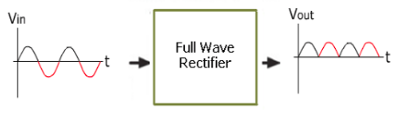

Figure:1

Filter :
A filter is a circuit capable of passing certain frequencies while attenuating other frequencies . Filters are used to eliminate undesired high frequencies that are present on AC input lines .
We filter the pulsating input signal so that it converts the pulsating output of the rectifier to a constant DC supply .

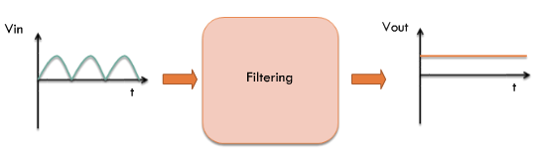
Figure:2
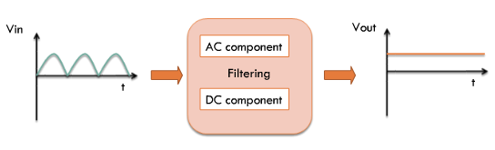
Figure:3

Filtering :
we can perform a simple kind of filtering by adding a capacitor with the rectifier . When we add a capacitor directly to the output of a rectifier AC components will face a low impedance path to ground and will not which will be seen in the output .

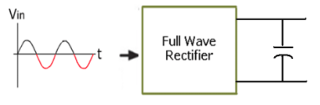

Figure:4

Full Wave Rectification + Filtering :

When we add a smoothing capacitor across the output of a full wave rectifier , it will convert the pulsating output to a constant DC output voltage . That means it will convert the full wave ripple output to the rectifier into a smooth DC output voltage .
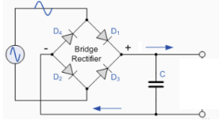

Figure:5

Ripple Voltage and Ripple Factor :
When we add a finite capacitor , in every half cycle a new charging pulse will occurs . So that the capacitor will charge and discharge very frequently . The smaller the V_{pp} , the more the waveform will resemble a pure DC voltage . The variable portion is known as ‘ripple’ and the value V_{pp} is known as the ripple voltage. The ratio of the ripple voltage to the DC or average voltage is known as the ripple factor. We can also say that, the ration between the AC component’s rms value and DC component’s rms value is known as Ripple Factor .

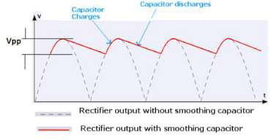

Figure:6

Filling the Gaps :
A capacitor-input filter will charge and discharge such that it fills in the “gaps” between each peak . This reduces variations of voltage . The remaining voltage variation is called ripple voltage .

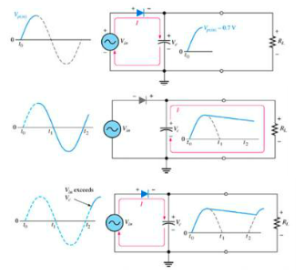

Figure:7

Choosing the Capacitor :
Its need to be careful when when choosing capacitor because of the load of the rectifier circuit . According to the description of the ripple factor we need to choose the capacitor . As low ripple factor described , choosing large capacitance is not practical. Large capacitance is cost more and will create higher peak currents in the transformer secondary and in the supply feeding it.

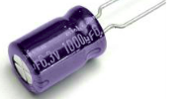

Figure:8

Half Wave vs Full Wave Capacitive Rectification :
The advantages of a full wave rectifier over a half-wave is quite clear .The capacitor can more effectively reduce the ripple when the time between peaks is shorter. And if the capacitance and voltage sources used are the same, then surely full wave rectifier will give lesser ripple effect beacuse the time between peaks is shorter in Full wave rectifier .
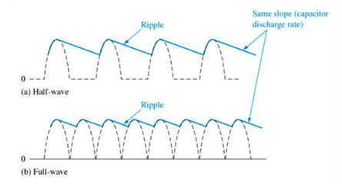
Figure:9

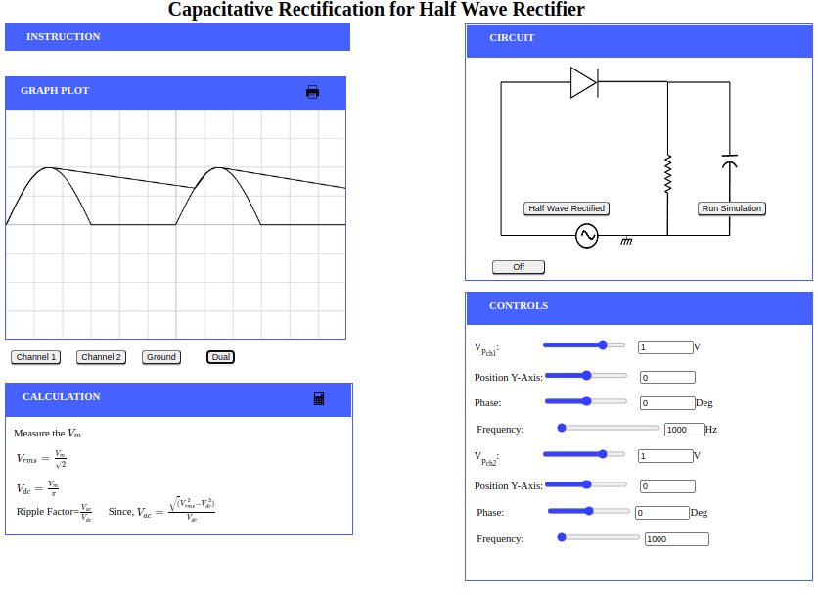

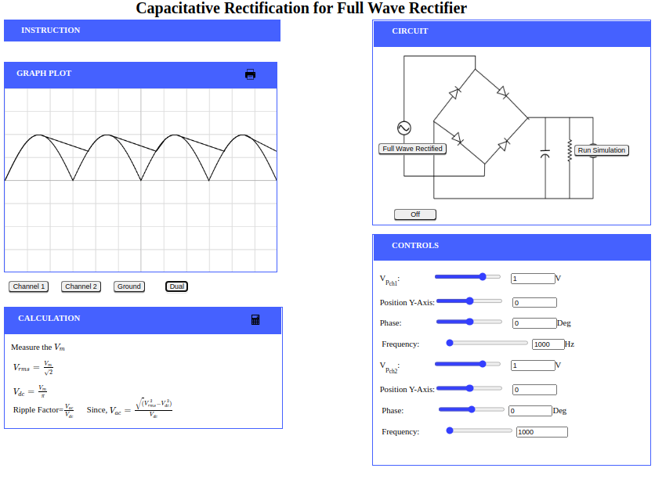

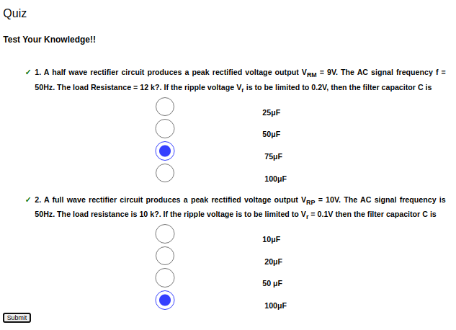

EXPERIMENT-6

Lab No: 6

Lab Name: Zener Diode As A Voltage Regulator

Theory:

Zener Diode And Its Function :

A Zener diode is a special type of diode designed to reliably allow current to flow backwards when a certain set reverse voltage, known as the Zener voltage, is reached. Zener diode allows current to flow both forward and reverse direction . So when the voltage is above the breakdown voltage or zener voltge it allows to flow the current in reverse direction . The Zener diode behaves just like a normal general-purpose diode consisting of a silicon PN junction when biased in the forward direction. In a standard diode, the Zener voltage is high, and the diode is permanently damaged if a reverse current above that value is allowed to pass through it. In the reverse bias condition , there are no reverse current flow until the breakdown voltage is reached practically . When this occurs there is a sharp increase in reverse current. Varying amount of reverse current can pass through the diode without damaging it. The breakdown voltage or zener voltage Vz across the diode remains relatively constant. The fact that the voltage across the diode in the breakdown region is almost constant turns out to be an important characteristic of the zener diode as it can be used in the simplest types of voltage regulator applications. Zener Diode can be used as a voltage regulator and there are two types of regulation: load regulation and line regulation.

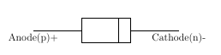

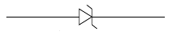

Figure:1 Figure:2

Zener Diode As A Voltage Regulator:

A voltage regulator is an electronic circuit that provides a stable DC voltage independent of the load current, temperature and AC line voltage variations. A Zener diode of break down voltage V_{Z} is reverse connected to an input voltage source VI across a load resistance R_{L} and a series resistor R_{S}. The voltage across the zener will remain steady at its break down voltage V_{Z} for all the values of zener current I_{Z} as long as the current remains in the break down region. Hence a regulated DC output voltage V₀=V_{Z} is obtained across R_{L}, whenever the input voltage remains within a minimum and maximum voltage. Basically there are two type of regulations such as:

Line Regulation :
In line regulation, series resistance and load resistance are fixed and only the input voltage is varying. Even if the input voltage is changing, the output voltage remains constant as long as the input voltage is maintained above minimum value.

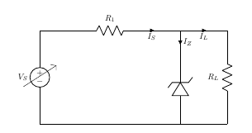

Figure:3

In Line Regulation, Load resistance is constant and input voltage varies. V_{I} must be sufficiently large to turn the Zener Diode ON.

V_{L} = V_{Z} = (Vi_{min} × R_{L}) / (R_{S}+R_{L})
So, the minimum turn-on voltage V_{Imin} is :
V_{imin}= ( V_{Z}×(R_{S}+R_{L}) ) / R_{L}
The maximum value of V_{I} is limited by the maximum zener current I_{Zmax}
I_{Rmax}=I_{Zmax}+I_{L}
I_{L} is fixed at :
V_{Z} / R_{L} Since,V_{L}=V_{Z}
So maximum V_{I} is
V_{imax} = V_{rmax} + V_{Z}

or,

V_{Imax}=I_{Rmax}×R+V_{Z}
For V_{I}<V_{Z},
V_{O}=V_{I}
For V_{I}>V_{Z},
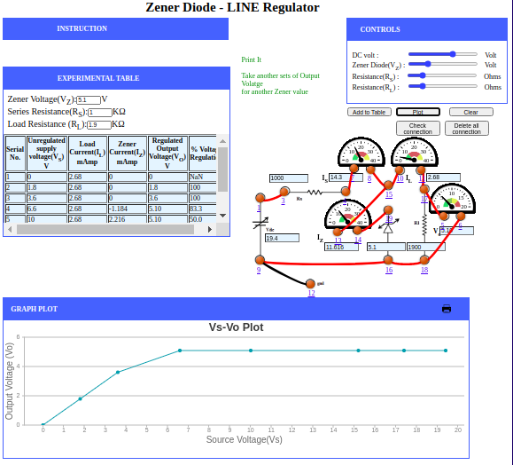
V_{O}=V_{I}−I_{S}×R_{S}

Load Regulation :
In load regulation, the input voltage, the series resistance is fixed and remains constant whereas the load resistance varies and keeps on changing. Output volt remains same, as long as the load resistance is maintained above a minimum value.

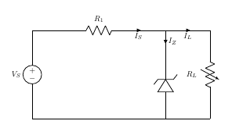

Figure:4

In Load Regulation , input voltage is constant and Load resistance varies. Too small a Load Resistance R_{L} ,will result in V_{Th}<V_{Z} and Zener Diode will be OFF.

V_{L} = V_{Z} = (V_{Imin}×R_{L} ) /(R_{S}+R_{L})
So the minimum load resistance R_{L}

R_{lmin}= (V_{Z}×R_{S} ) / (V_{I}−V_{Z})
Any load resistance greater than R_{Lmin} will make Zener Diode ON

I_{S}=I_{L}+I_{Z}
RLmin will establish maximum IL as
I_{lmax} = V_{L} /R_{lmin} =V_{Z} / R_{lmin} Since,V_{L}=V_{Z}
V_{S} is the voltage drop across R_{S}
V_{S}=V_{Imin}−V_{Z}
I_{S} = (V_{Imin}−V_{Z} )/ RS
For R_{L} < R_{Lmin},
V_{O}=V_{I}
For R_{L} > R_{Lmin,}
V_{O}=V_{I}−I_{S}×R_{S}
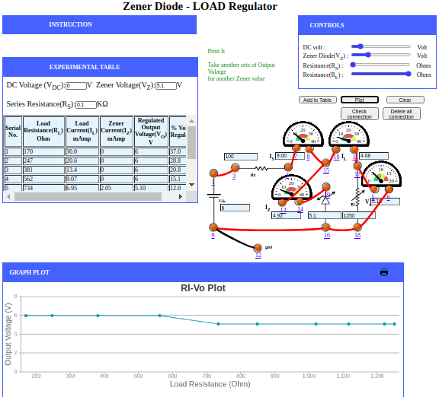

Zener Characteristics :

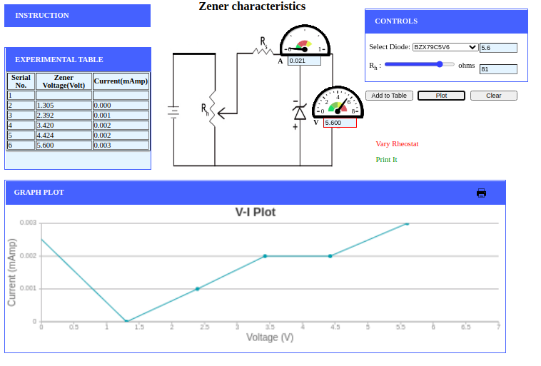

Quiz :
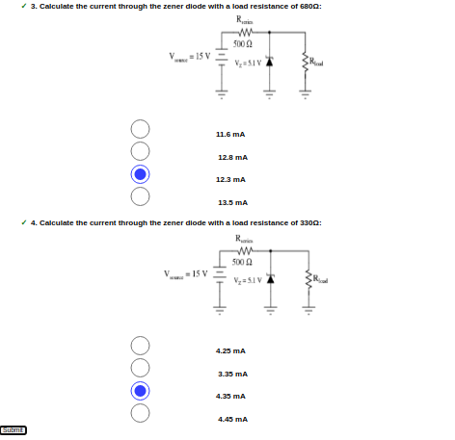

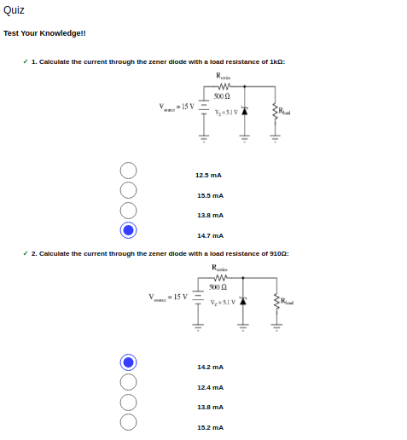

EXPERIMENT-7

Lab No: 7

Lab Name: BJT Common Emitter Characteristics

Theory:

Structure of Bipolar Junction Transistor
A bipolar junction transistor, BJT, is a single piece of silicon with two back-to-back P-N junctions. BJTs can be made either as PNP or as NPN.
There are total 3 regions and 3 terminals which are emitter (E) , base (B) and collector (C ) . IN the pictures given Below arrows indicates the current flow in the emitter .

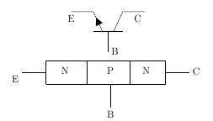
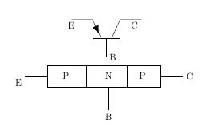

Pic 1 : NPN transistor Pic 2 : PNP transistor

Emitter :
Emitter supply electrons which are free charge carriers in n-p-n or holes in p-n-p transistors. It is the left region . These majority carriers are injected in the p region of n-p-n or holes in the n region of p-n-p transistor . Emitter is a heavily doped region to supply a large number of majority carriers into the base.

Base:
In base region , two p-type layers or two n-type layers are sandwiched . It is the middle region. This region is thin and very lightly doped . The majority carriers from the emitter region are injected into this region.

Collector :
In collector region charge carriers are collected . It locates at the right side . This is the largest region among all regions . The doping level of this region is intermediate between heavily doped emitter region and lightly doped base region .

Operation of Bipolar Junction Transistor

There are 4 regions of bipolar junction transistor :
- Cut-off Region: Base-emitter junction is reverse biased. No current flow.
- Saturation Region: Base-emitter junction is forward biased and Collector-base junction is forward biased.
- Active Region: Base-emitter is junction forward biased and Collector-base junction is reverse biased.
- Breakdown Region: I_{C} and V_{CE} exceed specifications and can cause damage to the transistor.

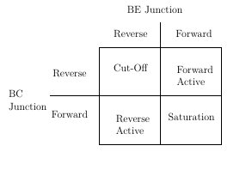

Cut-off Region:
In cut-off regions both emiter-base region and collector-base regions are reverse biased that is (V_{BE}<0) and (V_{CB}>0) respectively . The currents are zero also. .There are some leakage currents associated with reverse biased junctions,but these currents are small and therefore can be neglected . Application : open switch

Forward Active Region :
In Forward Active region Base-emitter junction is forward biased and Collector-Base junction is reverse biased that is (V_{BE}>0) and (V_{CB}>0) . In this case, the forward bias of the BE junction will cause the injection of both holes and electrons across the junction. The holes are of little consequence because the doping levels are adjusted to minimize the hole current. The electrons are the carriers of interest. The electrons are injected into the base region where they are called the minority carrier even though they greatly outnumber the holes.
Application:Amplifier in analog circuits

I_{C}=−α_{F}×I_{E}+I_{CO}
where,
α_{F} is the forward current transfer ratio
I_{CO} is Collector reverse saturation current

Saturation Region :
In Saturation region both base-emitter junction and also collector-Base junction are forward biased that is (V_{BE} >0) and (V_{CB}<0).Voltage drop is small across the collector junction. Maximum current flows through the transistor . The transistor also does not respond to any change in emitter current or base-emitter voltage . Application : closed switch .

Reverse Active Region :
In Reverse Active region base-emitter junction is reverse biased that is (V_{BE}<0) and collector-Base junction is forward biased (V_{CB}<0). Except all voltage sources,the operation is just the same as the forward active region, and hence collector and emitter currents, are the reverse of the forward bias case. The current gain in this mode is smaller than that of forward active mode for which this mode in general unsuitable for amplification.
Application:In digital circuits and analog switching circuits.

I_{E}=−α_{R}∗I_{C}+I_{EO}
Here,
α_{R} is the reverse current transfer ratio
I_{EO} is the Emitter reverse saturation current

BJT -Common Emitter Circuit :
The DC behavior of the BJT can be described by the Ebers-Moll Model. The equations for the model are:
I_{F}=I_{ES}×(exp ^{(VBE /VT)−1})

I_{R}=I_{CS}×(exp^{(VCB /VT)−1})
where,
I_{ES} is base-emitter saturation currents,
I_{CS} is base-collector saturation currents

V_{T}=(k×T) / q
where,
k is the Boltzmann’s constant ( k = 1.381 e⁻²³ V.C/ K ),
T is the absolute temperature in degrees Kelvin, and
q is the charge of an electron (q = 1.602 e⁻¹⁹ C).
β_{F}=α_{F} / (1−α_{F})
β_{R}=α_{R} / (1−α_{R})
where,
β_{F} is large signal forward current gain of common-emitter configuration,
β_{R} is the large signal reverse current gain of the common-emitter configuration
α_{F}=β_{F} / (1+β_{F} )

α_{R}=β_{R} ( 1+β_{R} )
where,
α_{R} is large signal reverse current gain of a common-base configuration,
α_{F} is large signal forward current gain of the common-base configuration.
I_{C} = α_{F} × I_{F} − I_{R}

I_{E} = −I_{F} + α_{R} ∗ I_{R}

I_{B}=(1−α_{F})×I_{F}+(1−α_{R})×I_{R}
The forward and reverse current gains are related by the expression
α_{R}×I_{CS} = α_{F}×I_{ES} =I_{S}
where,
IS is the BJT transport saturation current.
The parameters αR and αF are influenced by impurity concentrations and junction depths.
The saturation current, IS , can be expressed as
I_{S}=J_{S}×A
where,
A is the area of the emitter and
J_{S} is the transport saturation current density

Input Characteristics
The most important characteristic of the BJT is the plot of the base current, I_{B}, versus the base-emitter voltage,V_{BE}, for various values of the collector-emitter voltage,V_{CE}

I_{B}= ϕ (V_{BE} , V_{CE}) for constant V_{CE}
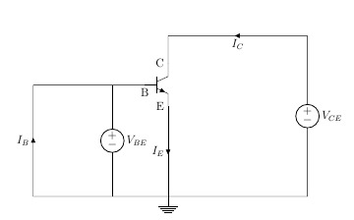

Output Characteristics
The most important characteristic of the BJT is the plot of the collector current, I_{C}, versus the collector-emitter voltage,V_{CE}, for various values of the base current, I_{B} as shown on the circuit on the right.

I_{C} = ϕ (V_{CE} , I_{B}) for constant I_{B}

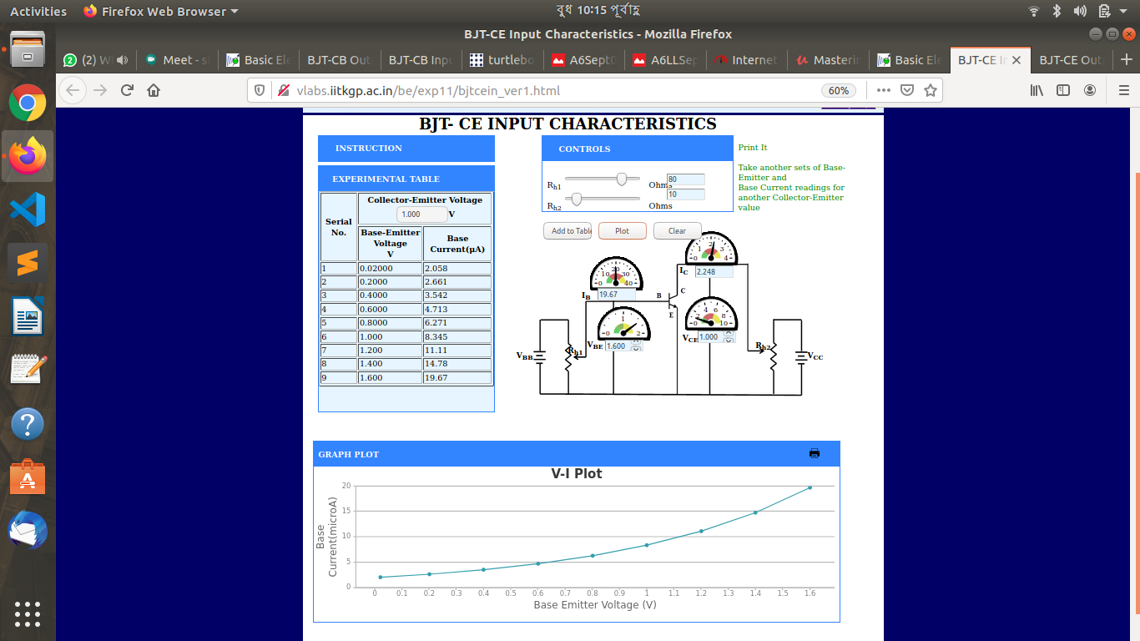
Input characteristic:

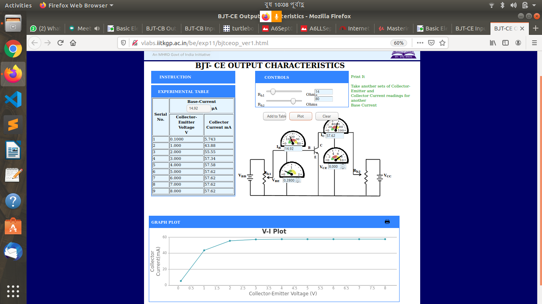
Output Characteristics :

Quiz :
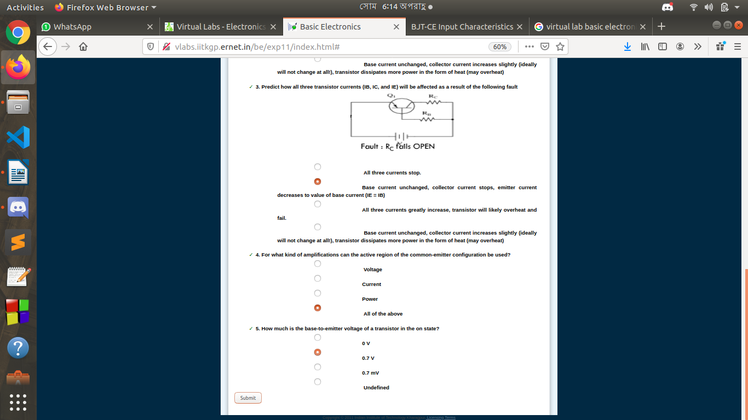
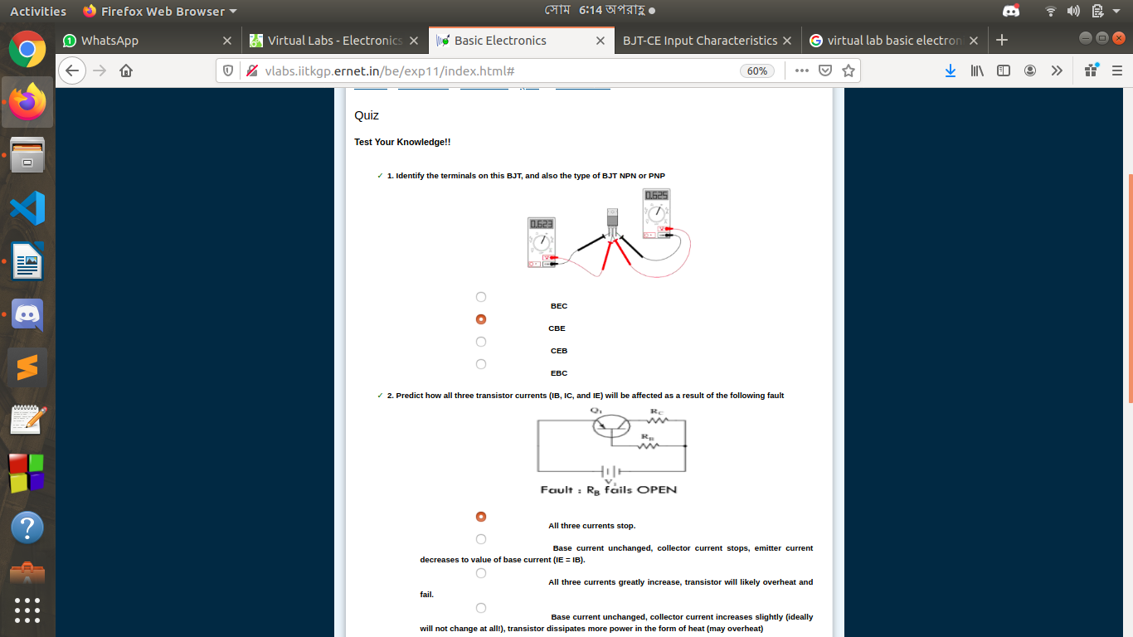

EXPERIMENT-8

Lab No: 8

Lab Name: BJT Common Base Characteristics

Theory:

Structure of Bipolar Junction Transistor
A bipolar junction transistor, BJT, is a single piece of silicon with two back-to-back P-N junctions. BJTs can be made either as PNP or as NPN.
There are total 3 regions and 3 terminals which are emitter (E) , base (B) and collector (C ) . IN the pictures given Below arrows indicates the current flow in the emitter .

Pic 1 : NPN transistor Pic 2 : PNP transistor

Emitter :
Emitter supply electrons which are free charge carriers in n-p-n or holes in p-n-p transistors. It is the left region . These majority carriers are injected in the p region of n-p-n or holes in the n region of p-n-p transistor . Emitter is a heavily doped region to supply a large number of majority carriers into the base.

Base:
In base region , two p-type layers or two n-type layers are sandwiched . It is the middle region. This region is thin and very lightly doped . The majority carriers from the emitter region are injected into this region.

Collector :
In collector region charge carriers are collected . It locates at the right side . This is the largest region among all regions . The doping level of this region is intermediate between heavily doped emitter region and lightly doped base region .

Operation of Bipolar Junction Transistor

There are 4 regions of bipolar junction transistor :
- Cut-off Region: Base-emitter junction is reverse biased. No current flow.
- Saturation Region: Base-emitter junction is forward biased and Collector-base junction is forward biased.
- Active Region: Base-emitter is junction forward biased and Collector-base junction is reverse biased.
- Breakdown Region: I_{C} and V_{CE} exceed specifications and can cause damage to the transistor.

Cut-off Region:
In cut-off regions both emiter-base region and collector-base regions are reverse biased that is (V_{BE}<0) and (V_{CB}>0) respectively . The currents are zero also. .There are some leakage currents associated with reverse biased junctions,but these currents are small and therefore can be neglected . Application : open switch

Forward Active Region :
In Forward Active region Base-emitter junction is forward biased and Collector-Base junction is reverse biased that is (V_{BE}>0) and (V_{CB}>0) . In this case, the forward bias of the BE junction will cause the injection of both holes and electrons across the junction. The holes are of little consequence because the doping levels are adjusted to minimize the hole current. The electrons are the carriers of interest. The electrons are injected into the base region where they are called the minority carrier even though they greatly outnumber the holes.
Application:Amplifier in analog circuits

I_{C}=−α_{F}×I_{E}+I_{CO}
where,
α_{F} is the forward current transfer ratio
I_{CO} is Collector reverse saturation current

Saturation Region :
In Saturation region both base-emitter junction and also collector-Base junction are forward biased that is (V_{BE} >0) and (V_{CB}<0).Voltage drop is small across the collector junction. Maximum current flows through the transistor . The transistor also does not respond to any change in emitter current or base-emitter voltage . Application : closed switch .

Reverse Active Region :
In Reverse Active region base-emitter junction is reverse biased that is (V_{BE}<0) and collector-Base junction is forward biased (V_{CB}<0). Except all voltage sources,the operation is just the same as the forward active region, and hence collector and emitter currents, are the reverse of the forward bias case. The current gain in this mode is smaller than that of forward active mode for which this mode in general unsuitable for amplification.
Application:In digital circuits and analog switching circuits.

I_{E}=−α_{R}∗I_{C}+I_{EO}
Here,
α_{R} is the reverse current transfer ratio
I_{EO} is the Emitter reverse saturation current

BJT -Common Emitter Circuit :
The DC behavior of the BJT can be described by the Ebers-Moll Model. The equations for the model are:
I_{F}=I_{ES}×(exp ^{(VBE /VT)−1})

I_{R}=I_{CS}×(exp^{(VCB /VT)−1})
where,
I_{ES} is base-emitter saturation currents,
I_{CS} is base-collector saturation currents

V_{T}=(k×T) / q
where,
k is the Boltzmann’s constant ( k = 1.381 e⁻²³ V.C/ K ),
T is the absolute temperature in degrees Kelvin, and
q is the charge of an electron (q = 1.602 e⁻¹⁹ C).
β_{F}=α_{F} / (1−α_{F})
β_{R}=α_{R} / (1−α_{R})
where,
β_{F} is large signal forward current gain of common-emitter configuration,
β_{R} is the large signal reverse current gain of the common-emitter configuration
α_{F}=β_{F} / (1+β_{F} )

α_{R}=β_{R} ( 1+β_{R} )
where,
α_{R} is large signal reverse current gain of a common-base configuration,
α_{F} is large signal forward current gain of the common-base configuration.
I_{C} = α_{F} × I_{F} − I_{R}

I_{E} = −I_{F} + α_{R} ∗ I_{R}

I_{B}=(1−α_{F})×I_{F}+(1−α_{R})×I_{R}
The forward and reverse current gains are related by the expression
α_{R}×I_{CS} = α_{F}×I_{ES} =I_{S}
where,
IS is the BJT transport saturation current.
The parameters αR and αF are influenced by impurity concentrations and junction depths.
The saturation current, IS , can be expressed as
I_{S}=J_{S}×A
where,
A is the area of the emitter and
J_{S} is the transport saturation current density

Input Characteristics
The most important characteristic of the BJT is the plot of the base current, I_{B}, versus the base-emitter voltage,V_{BE}, for various values of the collector-emitter voltage,V_{CE}

I_{B}= ϕ (V_{BE} , V_{CE}) for constant V_{CE}

Output Characteristics
The most important characteristic of the BJT is the plot of the collector current, I_{C}, versus the collector-emitter voltage,V_{CE}, for various values of the base current, I_{B} as shown on the circuit on the right.

I_{C} = ϕ (V_{CE} , I_{B}) for constant I_{B}

Input Characteristics :
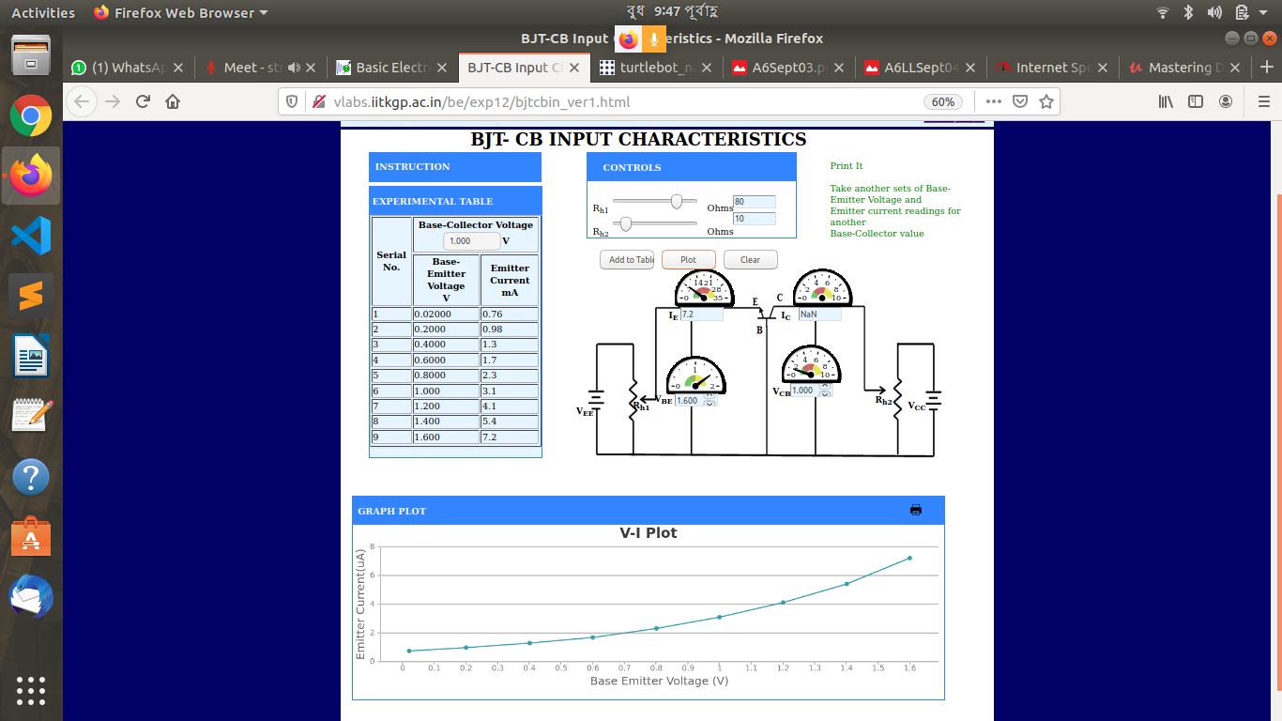

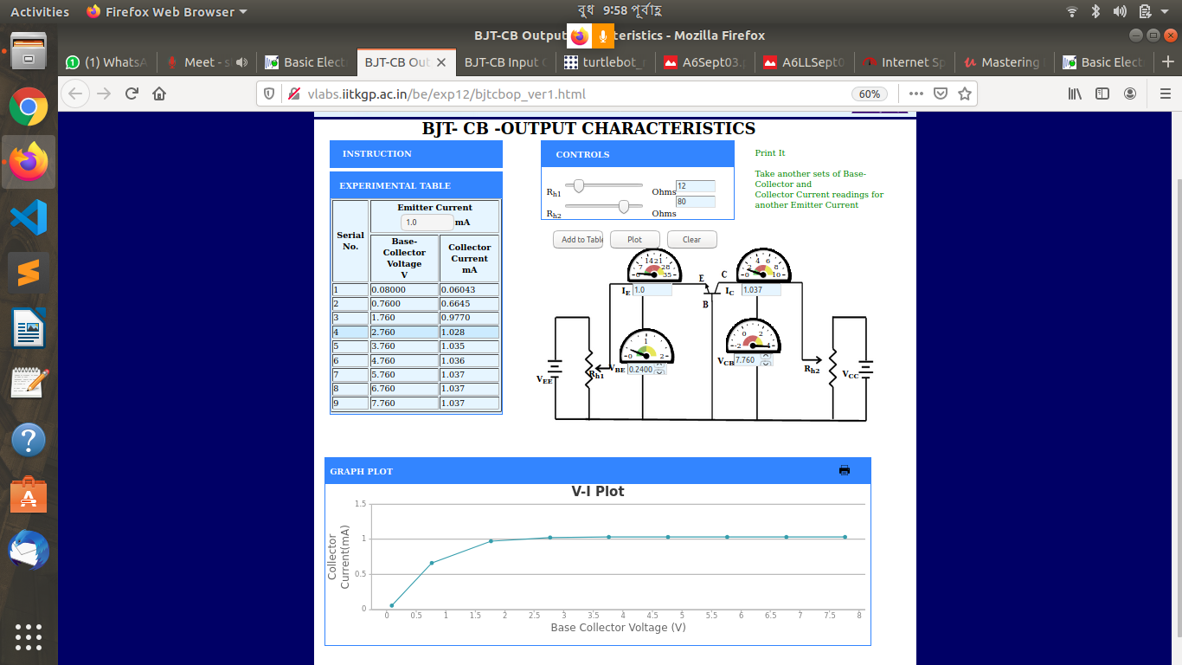
Output Characteristics:

Quiz :
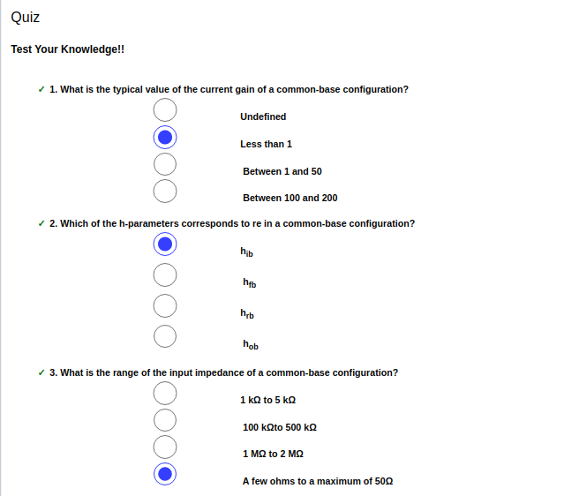
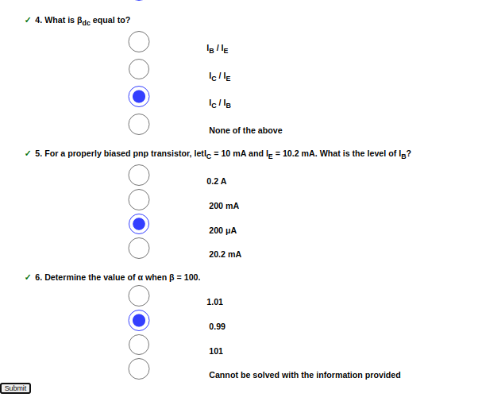

EXPERIMENT-9

Lab No: 9

Lab Name: BJT CE Amplifier

Theory:

The common emitter configuration has both voltage and current amplification . The common emitter amplifier is a three basic single-stage bipolar junction transistor and is used as a voltage amplifier . There are 2 resistors from voltage divider across the base transistor which are R_{B1} and R_{B2 .} It provides necessary bias condition and make sure that the emitter-base junction is operating in the correct region . When operating point is in the active region and biasing is done , then transistor operates as an amplifier . In a amplifier , the load line is bisected because of the Q-point . In practical design V_{CE} is always set to V_{CC}/2 . So that , Q-point always swing between the active region. When the maximum input signal provides , without any distortion and clipping the output is produced .

The Bypass Capacitor :

To obtain the DC quiescent point stability , the emitter resistor R_{E} is required . Because of the inclusion of R_{E} in the circuit causes a decrease in amplification at higher frequencies , it is bypassed by a capacitor so that it acts as a short circuit for AC and contributes stability for DC quiescent condition . There the connection between the capacitor and emitter is parallel ,

X_{CE} << R_{E}

1 / (2×π×f×C_{E} )<<R_{E}

C_{E}>> 1 / (2×π×f×R_{E} )

The Input/ Output Coupling (or Blocking) Capacitor :

An amplifier amplifies the given AC signal . DC current should not enter the amplifier or load . So , DC current should be blocked to enter , in order to have noiseless transmission of a signal . By inserting a coupling capacitor between two stages it is possible to accomplish ,

X_{CC} << R_{i} × h_{ie}

1 / (2 × π × f × C_{C}) << R_{i} × h_{ie}

C_{C} >> 1 / (2 × π × f × (R_{i} × h_{ie}))
C_{C} - Output Coupling Capacitor
C_{B} - Input Coupling Capacitor

Frequency response of Common Emitter Amplifier :

To short circuit the emitter resistor , the emitter bypass capacitor are used which increases the gain at high frequency . The coupling and bypass capacitors cause the fall of the signal in the low frequency response of the amplifier because their impedance becomes large at low frequencies . The stray capacitances are effectively open circuits. In the mid frequency range large capacitors are effectively short circuits and the stray capacitors are open circuits, so that no capacitance appears in the mid frequency range. Hence the mid band frequency gain is maximum. At the high frequencies, the bypass and coupling capacitors are replaced by short circuits. The stray capacitors and the transistor determine the response.
The input resistance is medium and is essentially independent of the load resistance R_{L} . The output resistance is relatively high and is essentially independent of the source resistance.
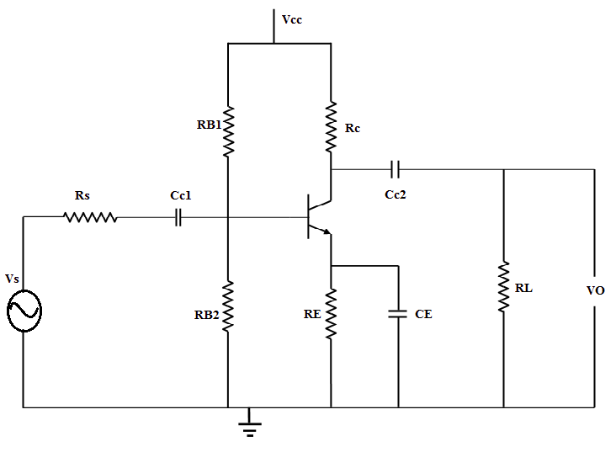
Figure: 1
The coupling capacitor, C_{C1} , couples the source voltage V_{S} to the biasing network. Coupling capacitor C_{C2} connects the collector resistance R_{C} to the load R_{L} . The bypass capacitance C_{E} is used to increase the midband gain, since it effectively short circuits the emitter resistance R_{E} at midband frequencies. The resistance R_{E} is needed for bias stability. The external capacitors C_{C1}, C_{C2}, C_{E} will influence the low frequency response of the common emitter amplifier. The internal capacitances of the transistor will influence the high frequency cut-off.

A(s)= A_{m}×S²×(S+w_{Z}) /
((S+w_{L1})×(S+w_{L2})×(S+w_{L3})×(1+S / w_{H}))

A_{M} is the midband gain,
w_{H} is the frequency of the dominant high frequency pole,
w_{L1}, w_{L2}, w_{L3} are low frequency poles introduced by the coupling and bypass capacitors,
w_{Z} is the zero introduced by the bypass capacitor.

The midband gain is obtained by short circuiting all the external capacitors and open circuiting the internal capacitors. Figure 2 shows the equivalent for calculating the midband gain.

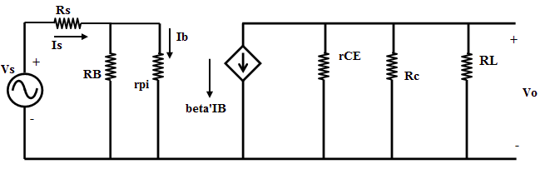
Figure: 2

Am=Vo / Vs= −β [ r_{CE} || R_{C} || R_{L} ] [ R_{B} / (R_{B} + r_{pi} )] [ 1 / (R_{S} + (R_{B} || r_{pi} ))]
It can be shown that the low frequency poles, w_{L1}, w_{L2}, w_{L3} can be obtained by the following equations:

τ₁ = 1 / w_{L1} = C_{C1} × R_{IN}
where,
R_{IN} = R_{S} + [R_{B} || r_{pi}]

τ₂ = 1 / w_{L2}= C_{C2} × [ R_{L} + ( R_{C} || r_{CE} )]

τ₃ = 1 / w_{L3}= C_{E} × R′_{E}

R′_{E} = R_{E} || [ (r_{pi} / (β_{F}+1 )) + (( R_{B} || R_{S} ) / ( β_{F} + 1 ))]

w_{Z} = 1 / (R_{E}×C_{E})

Normally, w_{Z}<w_{L3} and the low frequency cut-off w_{L} is larger than the largest pole frequency. The low frequency cut-off can be approximated as
w_{L}≅(√w_{L1})²+(w_{L2})²+(w_{L3})²
The high frequency equivalent circuit of the common-emitter amplifier is shown in Figure 3.

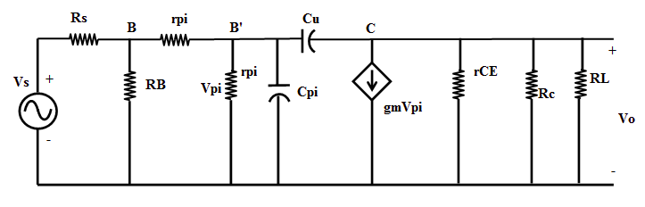
Figure: 3

In Figure 3, Cμ is the collector-base capacitance, Cπ is the emitter to base capacitance, rX is the resistance of silicon material of the base region between the base terminal B and an internal or intrinsic base terminal B’. Using the Miller Theorem, it can be shown that the 3-dB frequency at high frequencies is approximately given as

w⁻¹_{H} = ( r_{pi} || [ r_{x} + ( R_{B} || R_{S} )]) × C_{T}

where,
C_{T} = C_{π} + C_{μ} [ 1 + g_{m} (R_{L} || R_{C})]

and
g_{m} = I_{C} / V_{T}

P.T.O.

CE Amplifier
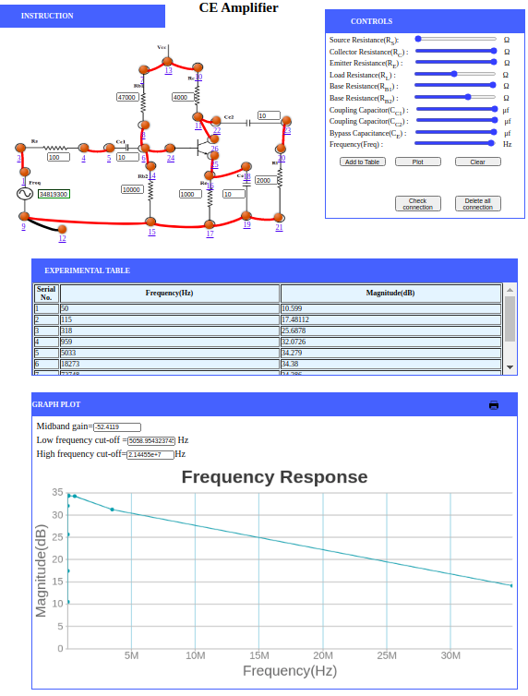
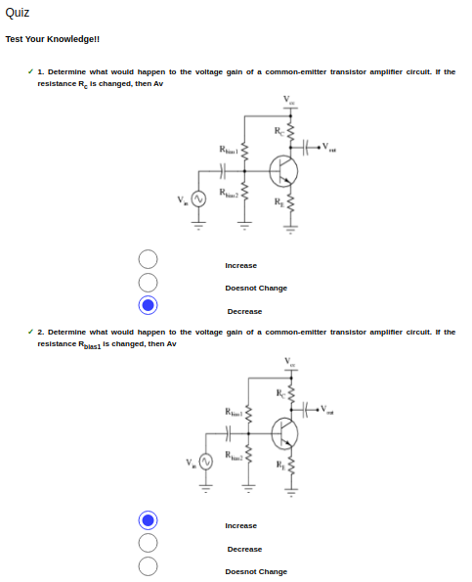
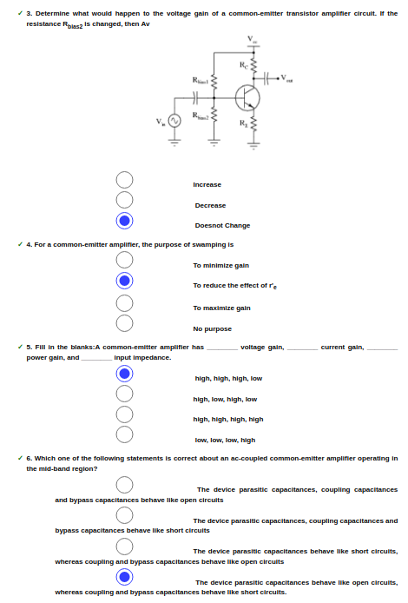
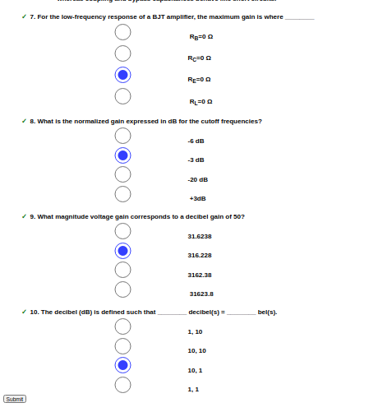
EXPERIMENT-10

Lab No: 10

Lab Name: RC Frequency Response

Theory:

RC Circuit as Filters :

A filter is a circuit capable of passing (or amplifying) certain frequencies while attenuating other frequencies. Thus, a filter can extract important frequencies from signals that also contain undesirable or irrelevant frequencies. The filters which are used commonly are given below :

1. Low Pass Filter : A low-pass filter (LPF) is a filter that passes signals with a frequency lower than a selected cutoff frequency and attenuates signals with frequencies higher than the cutoff frequency. The exact frequency response of the filter depends on the filter design. It passes low frequency and blocks high frequency . It only allows low frequency signals from 0Hz to its cut-off frequency, (f_{C}) point to pass while blocking those any higher.

2. High Pass Filter : A high-pass filter (HPF) is an electronic filter that passes signals with a frequency higher than a certain cutoff frequency and attenuates signals with frequencies lower than the cutoff frequency. The amount of attenuation for each frequency depends on the filter design . It passes high frequencies and blocks low frequencies. It only allows high frequency signals from its cut-off frequency, (f_{C}) point and higher to infinity to pass through while blocking those any lower.

3. Band Pass Filter : A band-pass filter (BPF) is a device that passes frequencies within a certain range and rejects (attenuates) frequencies outside that range. Filter passes only a relatively narrow range of frequencies. It allows signals falling within a certain frequency band setup between two points to pass through while blocking both the lower and higher frequencies either side of this frequency band.

Passive filters are made up of passive components such as resistors, capacitors and inductors and have no amplifying elements (transistors, op-amps, etc) so have no signal gain, therefore their output level is always less than the input.

RC Voltage Dividers :

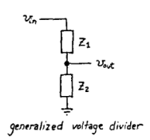
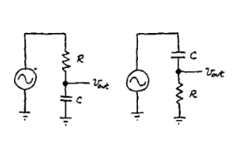

Figure:2 Figure:3
let RC circuits as voltage dividers ,
note that V_{out} = ( Z2/ Z1 + Z2 )*V_{in .}Since Z1 or Z2 is dependent upon frequency, the output is dependent upon the frequency of the input waveform.
RC as Low Pass Filter :
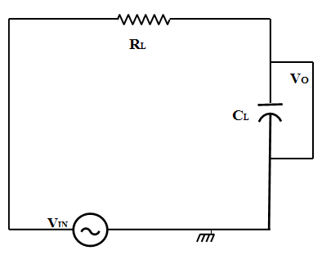

Figure:4
A single resistor and capacitor with a series connection can make a simple passive RC Low Pass Filter . Here input signal V_{in} is applied to the series combination between resistor and capacitor but the output signal is taken across the capacitor only . The reactance of a capacitor varies inversely with frequency , while the value of the resistor remains constant as the frequency changes. At low frequencies the capacitive reactance, (X_{C}) of the capacitor will be very large compared to the resistive value of the resistor,R. Voltage across the capacitor will be much larger than the voltage drop developed across the resistor. At high frequencies the reverse is true with (V_{C}) being small and (V_{R}) being large due to the change in the capacitive reactance value. Thus, low frequencies are passed and high frequencies are blocked.

Cut-off Frequency :
The cutoff frequency of an RC low-pass filter is the frequency at which the amplitude of the input signal is reduced by 3 dB . This value was chosen because a 3 dB reduction in amplitude corresponds to a 50% reduction in power . Thus, the cutoff frequency is also called the –3 dB frequency. The term bandwidth refers to the width of a filter’s pass band, and in the case of a low-pass filter, the bandwidth is equal to the –3 dB frequency The cutoff frequency (f_{c}) of an RC low-pass filter is calculated as follows:
f_{c}=1 / (2×π×R_{L}×C_{L})

Capacitive Reactance :
The reactance of a capacitor indicates the amount of opposition to current flow, but unlike resistance, the amount of opposition depends on the frequency of the signal passing through the capacitor. Thus, to calculate reactance at a specific frequency, following equation is used:
X_{C}=1/(2×π×f×C_{L} )
Z=√(R²_{L} + X²_{C})
Magnitude=20×log(X_{C} / Z)
V_{out}=V_{in}×(X_{C} / Z)

Low-Pass Filter Phase Shift :

90° of phase shift is introduced by each reactive element in a circuit which does not happen all at once . When the input frequency increases the phase of the output signal changes gradually like magnitude of the output signal . Capacitor is the only reactive element of the RC low-pass filter and as a result circuit introduced 90º of phase shift eventually .

ϕ=−arctan(2×3.14×f×C_{L}×R_{L})

High Pass Filter :

High pass filter can be made by connecting a single resistor and a single capacitor with series connection . Which will be a simple passive RC High Pass Filter . Where input signal (V_{in}) is applied to the series combination ,But the output signal (V_{out}) is taken across the resistor only .

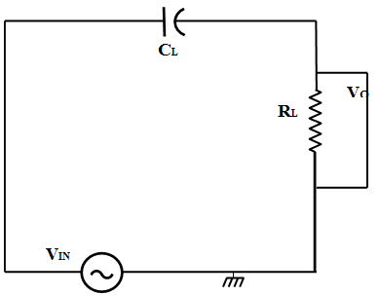

Figure:5

Here the capacitor acts as an open circuit because capacitor is very high at low frequency and until the cut-off frequency point (f_{C}) is reached , it blocks any input signals at (V_{in}) . The reactance of the capacitor act like allowing all of the input signal to pass directly to the output because when cut-off frequency has crossed the reactance of the capacitor has reduced sufficiently .
Magnitude=20×log (R / Z)
Vout=Vin×(R / Z)

RC Frequency Response : LPF
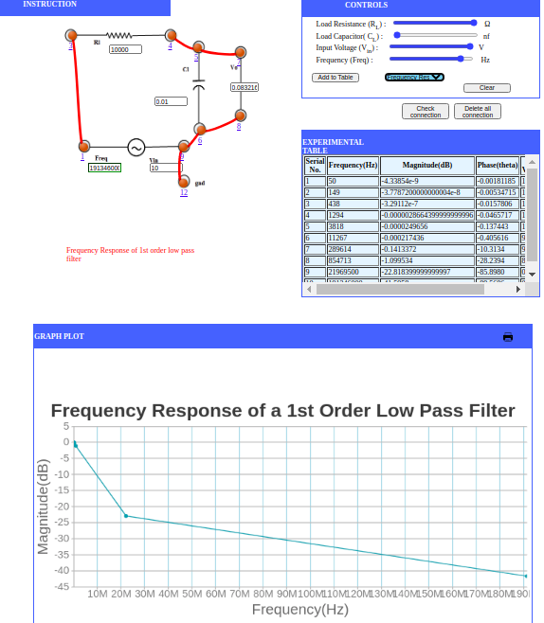

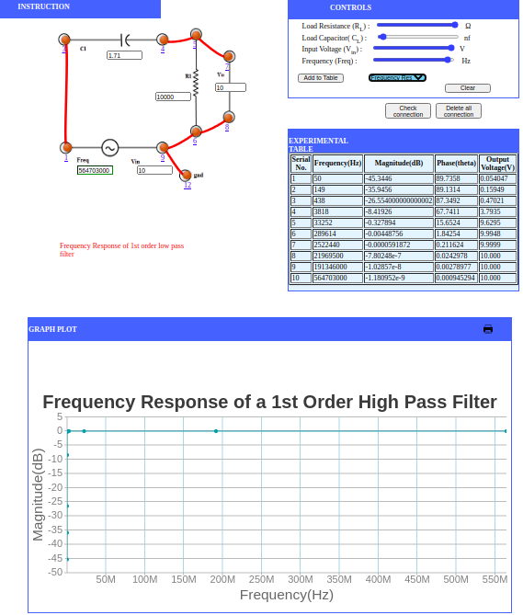
RC Frequency Response : HPF

Quiz :
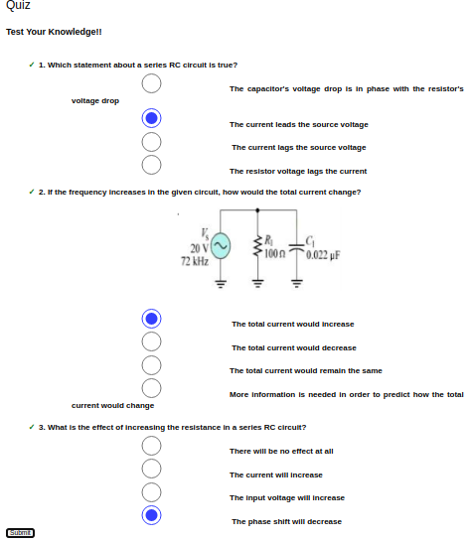

EXPERIMENT-11

Lab No: 11

Lab Name: To Explain RC Differentiator and Integrator

Theory:

OBJECTIVE
- To Explain charging of RC circuit with DC source
- To Explain discharging of RC circuit with DC source
- To Explain Square wave response of RC circuit
- To Explain RC circuit as Integrator
- To Explain RC circuit as Differentiator

THEORY:
RC Circuit as Filters
Q=CV is the static description of how capacitor behaves where Q is total charge and C is measure of how big the capacitor is and V is voltage across it.
I=C dV/dt is the dynamic description of how capacitors work which is just the time derivative of static description. C is constant wrt to time, I is date at which charge flows which means bigger the current faster the capacitor’s voltage changes.
Analogy
Think of Capacitor as a tub that can hold charge . A tub of large diameter( C), holds a lot of water ( Q ) for a given height( V). If you fill the tub within a thin straw ( small I) then water level – V- will rise slowly. If you use a large pipe(large V) then water level will rise faster. Similar for draining (discharging )tub. Of course a tub of larger diameter takes longer to fill than a tub of smaller diameter.
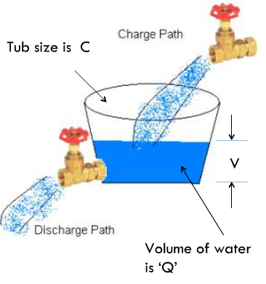

Charging With DC Source
The voltage across the capacitor approaches the applied voltage- but at a rate that diminishes towards zero as Vcap approaches the applied voltage . It starts out strongly charging at 10mA but as it is 1 V away it has slowed to 1/10 its rate.
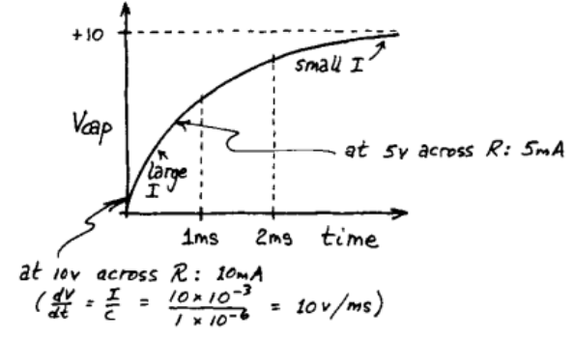
Charging With DC Source
- In 1 time constant = RC , the capacitor charges 63% of the way
- In 5 time constants = 5*RC, the capacitor charges 100% of the way
- Vcap never reaches Vapplies
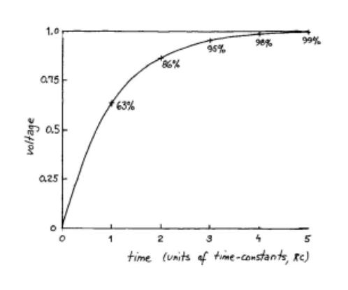
Discharging With DC Source
- Discharging follows similar principles to charging
- In 1 time constant = RC , the capacitor discharges 63% of the way
- In 5 time constants = 5*RC, the capacitor charges 100% of the way
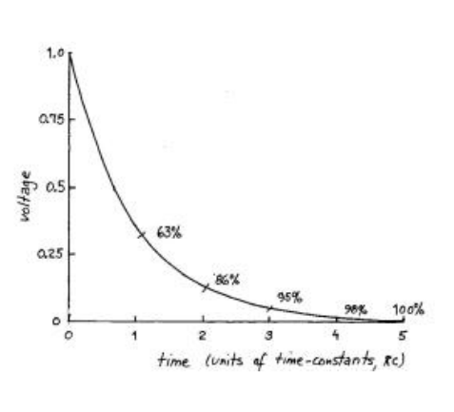
Square Wave Response Of RC Circuit
After studying how a constant source affects the charging-discharging of a RC , circuit , let us change the constant source to a source which changes very fast and observe the response of an RC Circuit.
We want to study the transient behaviour of the RC circuit when we suddenly change the voltage across the circuit . In order to do this we generate a square wave and observe the response of the voltage across the capacitor using an oscilloscope.

Characteristics Of A Square Wave
In the laboratory ,you will not study the response of an RC circuit to a single voltage step or voltage poulse , rather you will study the response to a periodic square wave with the waveform illustrated below-
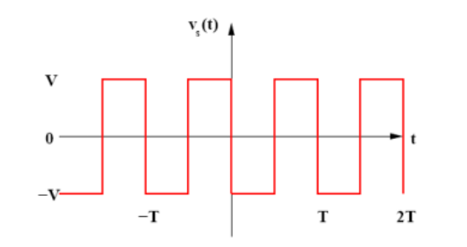
The pulse goes from - V to +V and has a period T. What is the response of the RC circuit to this period square wave?
Square Wave Response – Slow Change
Since we have seen that a time of 5T where T=R*C is needed for the capacitor to change fully , let us first take a time period of the square wave large enough to charge the capacitor. So,we take Time Period of Square wave >>RC . So in effect , this square wave is changing slowly.
Important Observations
These experiments were done in the time domain. However in this frequency domain a signal which changes fast would mean it’s high frequency signal ( or it has frequency components ), a signal which changes slowly would mean it has low frequency components and a signal which does not change very fast has medium frequency components. Clearly we saw the following response of RC circuit for the different frequencies as-

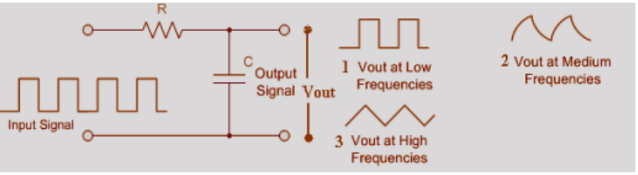
Figure:7

Integrators And Differentiators
What Is Integrator?
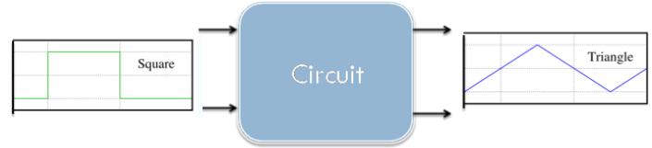
Figure:8
The Integrator is a circuit that converts or ‘integrates' a square wave input signal into triangular waveform output.
What Is Differentiator?
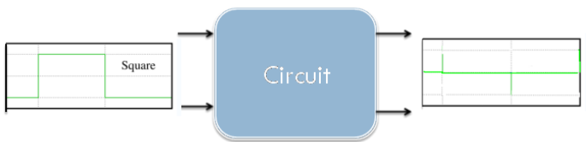
Figure:9
The Differentiator circuit converts or 'differentiates' a square wave input signal into high frequency spikes at its output.
RC As Integrators And Differentiator ?
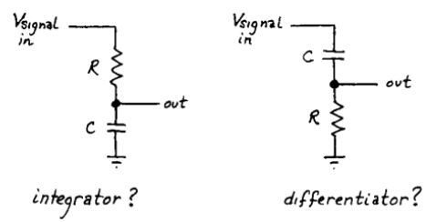
Figure:10
Can we exploit capacitor I=Cdv/dt to make differentiator and integrator?
RC Circuits As Differentiator
Basic Differentiation
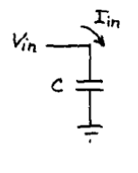
Figure:11
Consider this circuit – the current that flows in the capacitor is proportional to dV/dt – ie, the circuit differentiates the input signal . But – we really can’t measure the current here. Let us try to do that.

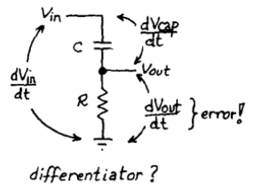
Figure:12
So, we put a resistor to measure the current but choose a very small resistor so that there will be very small voltage drop such that dVcap/dt ≈ dVin/dt .
RC As Differentiator
In an RC circuit if we take the voltage drop across R, and if we keep RC time constant is very short compared to the time period of the input waveform we will be differentiating the square wave.
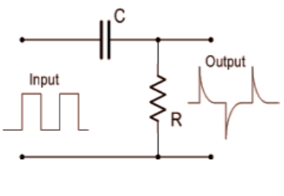
Figure:13
RC Circuit As Integrator
We Understand – Integrator
Figure:14
The Integrator is a circuit that converts or ‘integrates a square wave input signal into triangular waveform output.
Simple Integrator
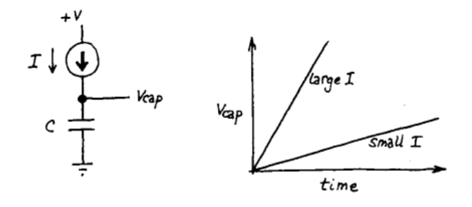
Figure:15
Consider this simple circuit – if we had a constant current source that flows in the capacitor, dVcap/dt – would be constant and we would have a ramp.
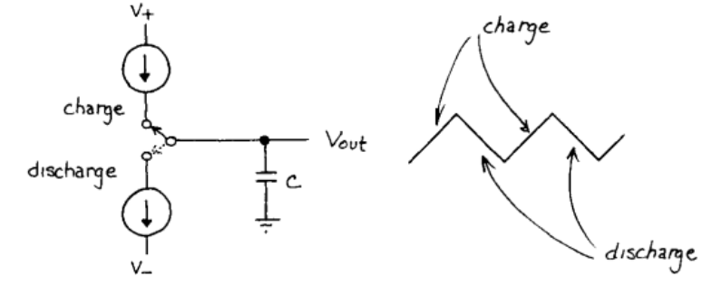
Figure:16
To generate a triangle wave – we can simply have the following setup .But of course – constant current sources are rare. So, how can we have this with a square wave generator?
RC As Integrator
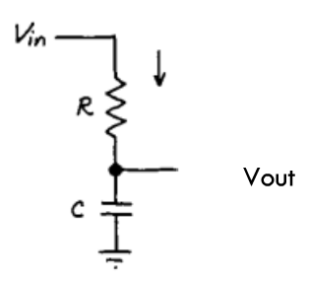
Figure:17

So, we put a resistor such that we can control the current and ideally try to have dV_{out}/dt to be a constant. Since the current does not change much during the initial part of the charging and discharging of the capacitor , the value of RC must be chosen such that it is large compared to the time period of the square wave.

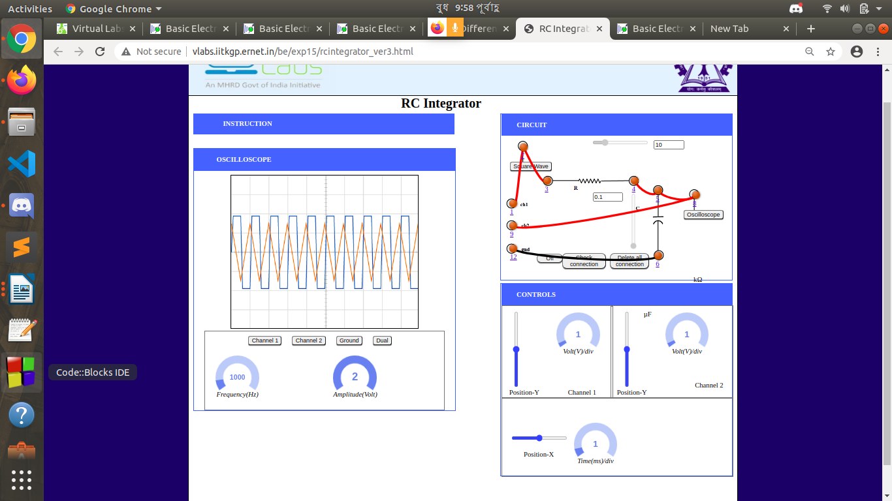
RC Integrator:

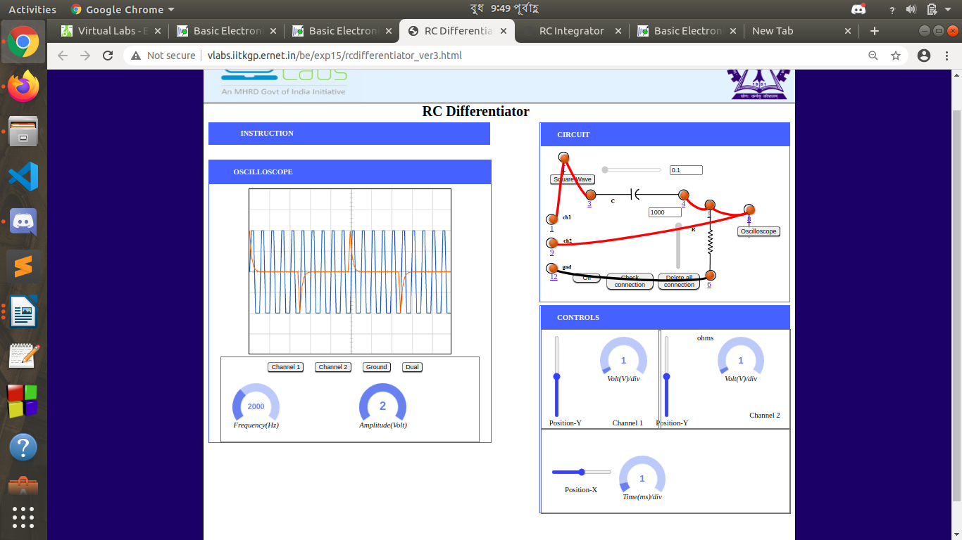
RC Differentiator :

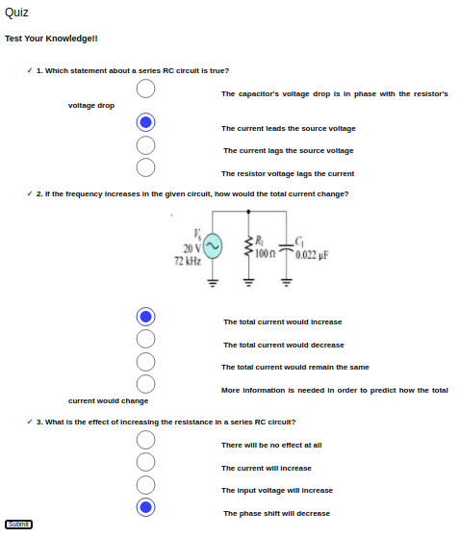

EXPERIMENT-12

Lab No: 12

Lab Name: Study of basic properties of operational amplifier: inverting and non-inverting amplifiers

Objectives :
At the end of the experiment, the student would be able to
- Explain Inverting Opamp
- Explain Non- Inverting Opamp
- Explain Gain

Theory:

INTRODUCTION:

Operational Amplifiers, or Op-amps as they are more commonly called, are one of the basic building blocks of Analogue Electronic Circuits. Operational amplifiers are linear devices that have all the properties required for nearly ideal DC amplification and are therefore used extensively in signal conditioning, filtering or to perform mathematical operations such as add, subtract, integration and differentiation.
An Operational Amplifier is fundamentally a voltage amplifying device designed to be used with external feedback components such as resistors and capacitors between its output and input terminals. These feedback components determine the resulting function or “operation” of the amplifier and by virtue of the different feedback configurations whether resistive, capacitive or both.
An Operational Amplifier is basically a three-terminal device which consists of two high impedance inputs. One of the inputs is called the Inverting Input, marked with a negative or “minus” sign, (–). The other input is called the Non-inverting Input, marked with a positive or “plus” sign (+). A third terminal represents the operational amplifiers output port which can both sink and source either a voltage or a current.
Op-Amp shows some properties that make it an ideal amplifier, its open loop gain and input impedance is infinite (i.e. practically very high), Output impedance and offset voltage is zero (i.e. practically very low) and bandwidth is infinite (i.e. practically limited to frequency where its gain become unity).
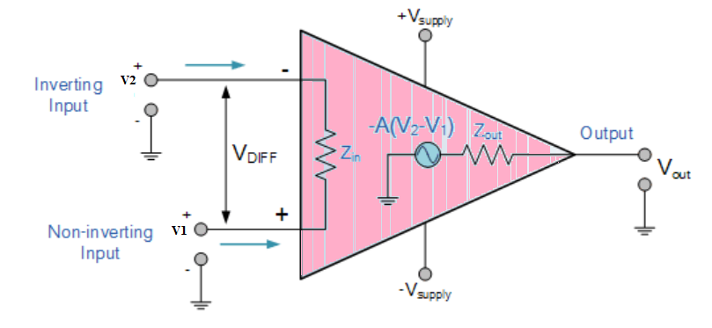

Inverting Operational Amplifier

The Inverting Operational Amplifier configuration is one of the simplest and most commonly used op-amp topologies. The Open Loop Gain, ( AVO ) of an operational amplifier can be very high, as much as 1,000,000 (120dB) or more.

However, this very high gain is of no real use to us as it makes the amplifier both unstable and hard to control as the smallest of input signals, just a few micro-volts, (μV) would be enough to cause the output voltage to saturate and swing towards one or the other of the voltage supply rails losing complete control of the output.
So to make it stable with a controllable gain, a feed back is applied through some external resistor (Rf) from its output to inverting input terminal(i.e., also known as negative feedback) resulting in reduced gain(closed loop gain, Av). So the voltage at inverting terminal is now the sum of the actual input and feedback voltages, and to separate both a input resistor (Ri) is introduced in the circuit. The non-inverting terminal of the op-amp is grounded, and the inverting terminal behaves like a virtual ground as the junction of the input and feedback signal are at the same potential.
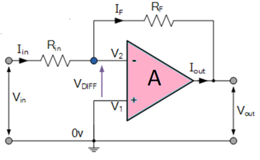
Current can be given
I=(V_{in}−V_{out})/(R_{in}+R_{F})

or,
I=(V_{in}−V₂)/R_{in}

or,
I=(V₂−V_{out})/R_{F}

I=(V_{in}/R_{in})−(V₂/R_{in})=(V₂/R_{F})−(V_{out}/R_{F})

So,
V_{in}/R_{in}=V₂×(1/R_{in}+1/R)−(V_{out}/R_{F})

and as, V2=0
I=(V_{in}−0)/R_{in}=(0−V_{out})/R_{F}

or,
R_{F}/R_{in}=−V_{out}/V_{in}

The close loop gain (Acl) is given by :-
A_{cl}=V_{out}/V_{in}=−R_{F}/R_{in}

Output voltage (V_{out}) is given by :-
V_{out}=−(R_{F}/R_{in})×V_{in}

NON-INVERTING OP-AMP
A non-inverting amplifier is an op-amp circuit configuration which produces an amplified output signal. This output signal of non-inverting op amp is in-phase with the input signal applied. In other words a non-inverting amplifier behaves like a voltage follower circuit. In this configuration of Op-amp the input signal is directly fed to the non-inverting terminal resulting in a positive gain and output voltage in phase with input as compared to inverting Op-amp where the gain is negative and output voltage is out of phase with input , and to stabalize the circuit a negative feedback is applied through a resistor(Rf) and the inverting terminal is grounded witha input resistor(R2).This inverting Op-Amp like layout the at inverting terminal creates a virtual ground at the summing point make the Rf and R2 a potential divider accross inverting terminal, Hence determines the gain of the circuit.

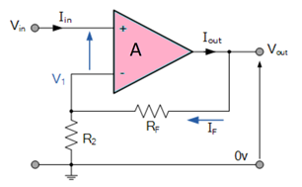

Potential difference V₁ can be written as
V₁=(R₂/(R₂+R_{F}))×V_{out}

in ideal condition :V₁=V_{in}
SO,
V_{in}=(R₂ / (R₂+R_{F}))×V_{out}

and as we know Gain Acl=Vout/Vin
Acl=V_{out}/V_{in}=(R₂+R_{F})/R₂=1+(R_{F}/R₂)

and Output Voltage (Vout) is given by:
V_{out}=[1+ R_{F} / R₂]∗V_{in}

Non-Inverting OPAMP :

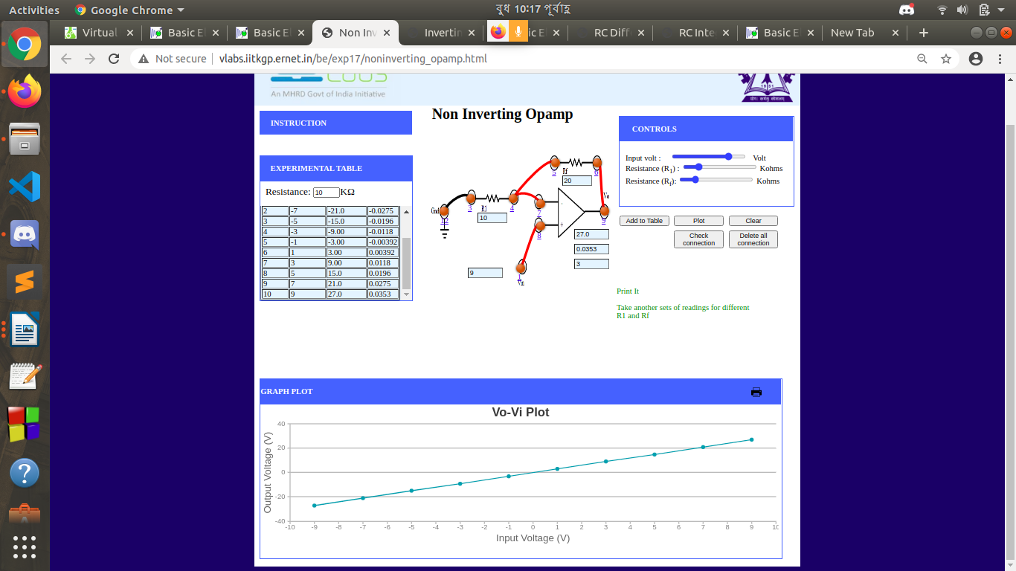

Inverting OPAMP :
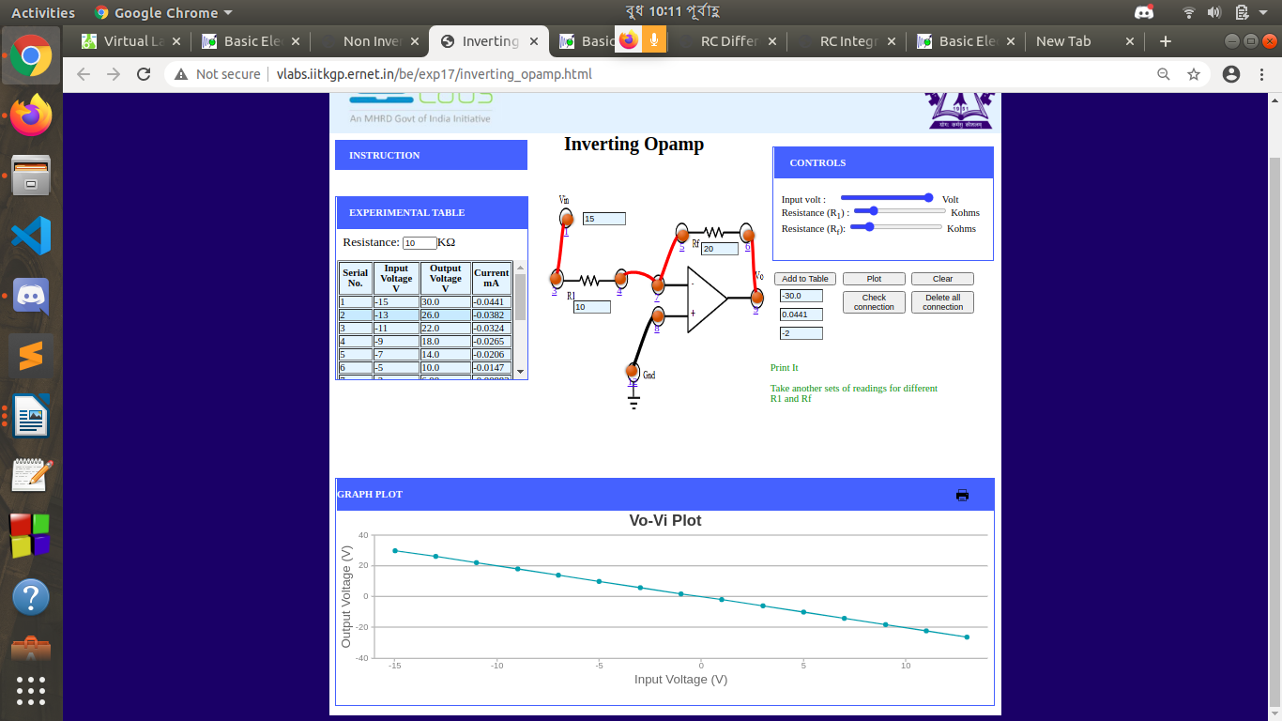

EXPERIMENT-13

Lab No: 13

Lab Name: Study of Differentiator and Integrator using Operational Amplifier

Objectives :

INTRODUCTION:

Operational Amplifiers, or Op-amps as they are more commonly called, are one of the basic building blocks of Analogue Electronic Circuits. Operational amplifiers are linear devices that have all the properties required for nearly ideal DC amplification and are therefore used extensively in signal conditioning, filtering or to perform mathematical operations such as add, subtract, integration and differentiation.
An Operational Amplifier is fundamentally a voltage amplifying device designed to be used with external feedback components such as resistors and capacitors between its output and input terminals. These feedback components determine the resulting function or “operation” of the amplifier and by virtue of the different feedback configurations whether resistive, capacitive or both.
An Operational Amplifier is basically a three-terminal device which consists of two high impedance inputs. One of the inputs is called the Inverting Input, marked with a negative or “minus” sign, (–). The other input is called the Non-inverting Input, marked with a positive or “plus” sign (+). A third terminal represents the operational amplifiers output port which can both sink and source either a voltage or a current.
Op-Amp shows some properties that make it an ideal amplifier, its open loop gain and input impedance is infinite (i.e. practically very high), Output impedance and offset voltage is zero (i.e. practically very low) and bandwidth is infinite (i.e. practically limited to frequency where its gain become unity).
THE INTEGREATOR :

As its name implies, the Integrator is an operational amplifier circuit that performs the mathematical operation of Integration, that is we can cause the output to respond to changes in the input voltage over time as the op-amp integrator produces an output voltage which is proportional to the integral of the input voltage. In other words the magnitude of the output signal is determined by the length of time a voltage is present at its input as the current through the feedback loop charges or discharges the capacitor as the required negative feedback occurs through the capacitor.
The integrator circuit layout is same as a inverting amplifier but the feedback resistor is replaced by a capacitor which make the circuit frequency dependent. In this case the circuit is derived by the time duration of input applied which results in the charging and discharging of the capacitor. Initially when the voltage is applied to integrator the uncharged capacitor allows maximum current to pass through it and no current flows through the Op-Amp due to the presence of virtual ground, the capacitor starts to charge at the rate of RC time constant and its impedence starts to increase with time and a potential diffrence is develops accross the capacitor resulting in charging current to decrease.This results in the ratio of capacitor's impedance and input resistance increasing causing a linearly increasing ramp output voltage that continues to increase until the capacitor becomes fully charged.
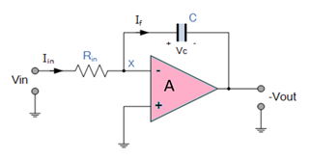
Since, the Output voltage is the potential difference accross capacitor.
V_{C}=Q/C

or,
V_{C}=V_{X}−V_{OUT}=−V_{OUT}

therefore −dV_{out}/dt=(1/C)×(dQ/dt)
dQ/dt is the current as the Vx is 0.
and input current can be written as
I_{IN}=(V_{IN}−0)/R_{IN}

and current through capacitor (If) can be written as
I_{f}=C×(dV_{out}/dt)=C×(1/C)×(dQ/dt)=dQ/dt

Assuming the ideal Op-amp its input impedance is infinite so no current pass through it.
I_{IN}=I_{f}=V_{IN}/R_{IN}=C×(dV_{out}/dt)

therefore,
(V_{IN}/V_{OUT})×(dt / (R_{IN}×C))=1

so,
V_{OUT}=−(1/(R_{IN}×C))∫V_{in}.dt

or,
V_{OUT}=−(1/(j×ωR_{IN}×C))×V_{IN}

THE DIFFERENTIATOR:
The differentiator circuit performs the mathematical operation of Differentiation, that is it “produces a voltage output which is directly proportional to the input voltage’s rate-of-change with respect to time“. In other words the faster or larger the change to the input voltage signal, the greater the input current, the greater will be the output voltage change in response, becoming more of a “spike” in shape. The basic operational amplifier differentiator circuit produces an output signal which is the first derivative of the input signal.
In the differentiator circuit the input is connected to the the inverting output of the Op-Amp through a capacitor(C) and a negetive feedback is provided to the inverting input terminal through a resistor(Rf), which is same as an integrator circuit with feedback capacitor and input resistor being replaced with each other. Here the circuit performs a mathematical differentiation operation, and the output is the first derivative of the input signal, 180' out of phase and apmlified with a factor Rf*C. The capacitor on the input allows only the AC component and restrict the DC, at low frequency the reactance of capicitor is very high causing a low gain and high frequency vice varsa but and high frequency the circuit becomes unstable.

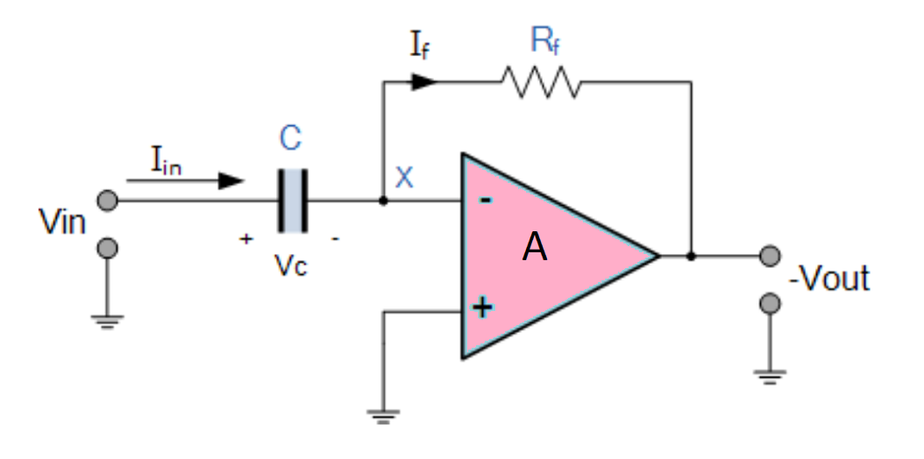

Since, the node voltage V_{x} is 0
I_{IN}=I_{f}=−V_{OUT}/R_{f}

The charge accross capacitor is given by,
Q=C×V_{IN}

The rate of change of charge is:
dQ/dt=C×(dV_{IN}/dt)

and we know that dQ/dt is capacitor current,
I_{f}=C×(dV_{IN}/dt)=I_{IN}

Therefore from eq. 4.1 and 4.4,
−V_{OUT}/R_{f}=C×(dV_{IN}/dt)

and Output voltage is
V_{OUT}=−R_{f}×C×(dV_{IN}/dt)

INTEGRATOR USING OPAMP:

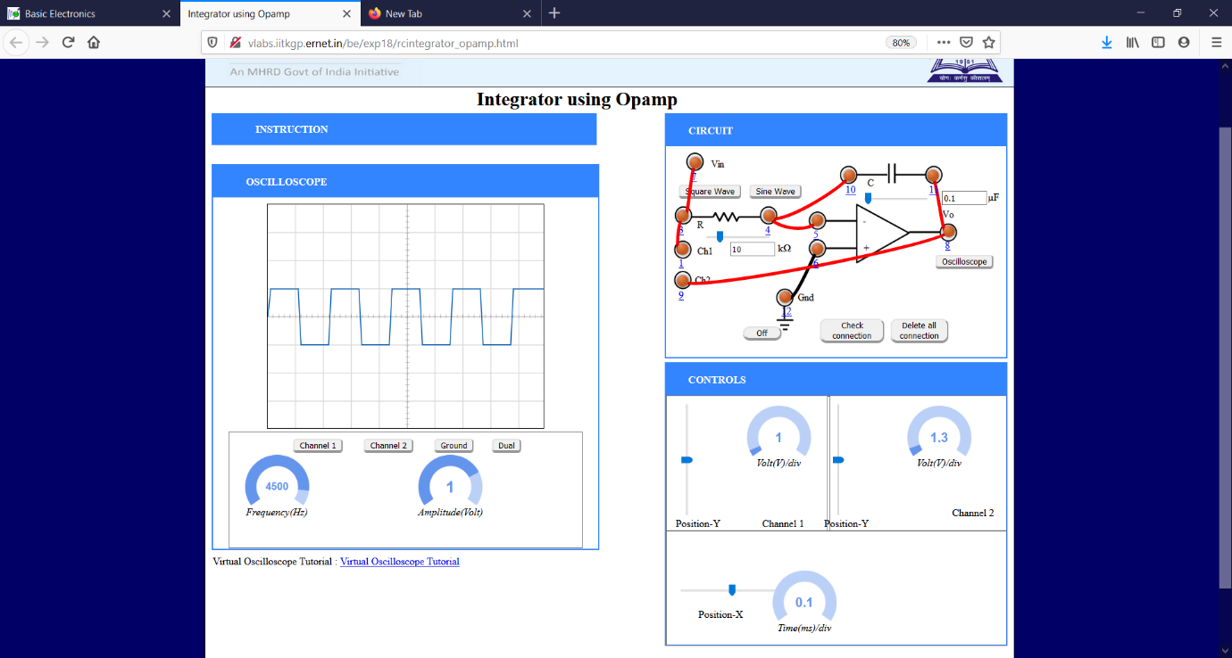

DIFFERENTIATOR USING OPAMP:



